

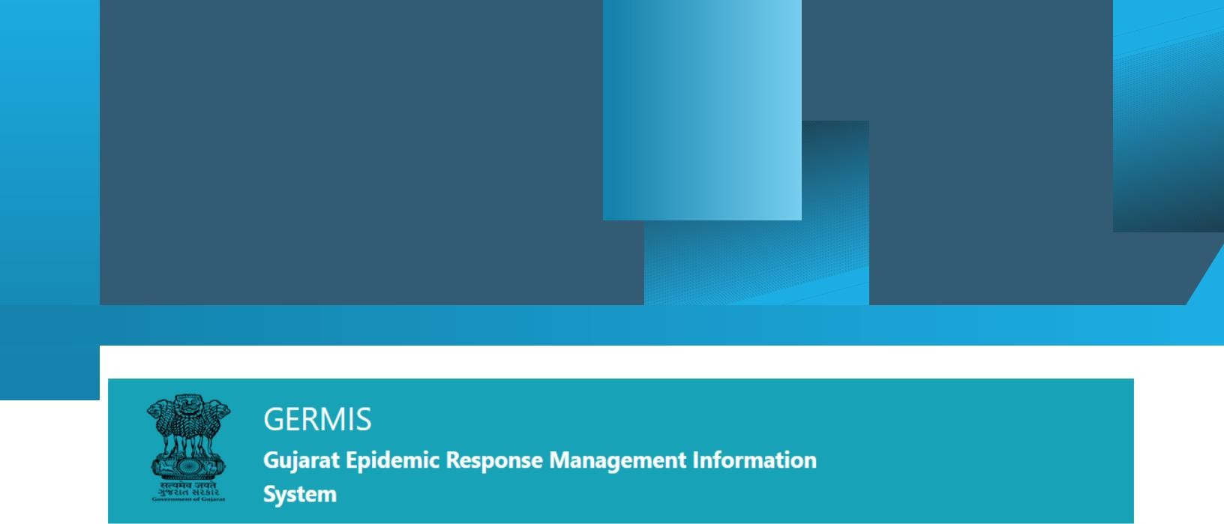

GERMIS USER GUIDELINES

Date: 23-07-2021

Facilitator: GERMIS (Gujarat Epidemic Response Management Information System)

Goals

* GERMIS Website and Public Dashboard
* GERMIS Internal Dashboard and MIS
* GERMIS Mobile Application

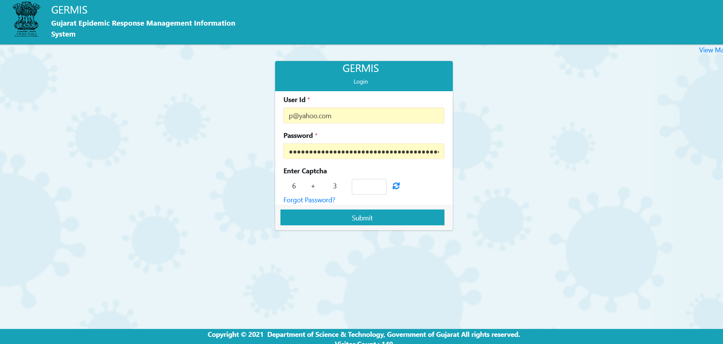

We can login using above form in GERMIS system and we can check further dashboard details, Hospital details, facility details after login process. We must to follow above steps for login.

## Add user name

* Add password

## Add Catcha code



Developed Dashboard in GERMIS.

🡪State Dashboard

🡪District Dashboard

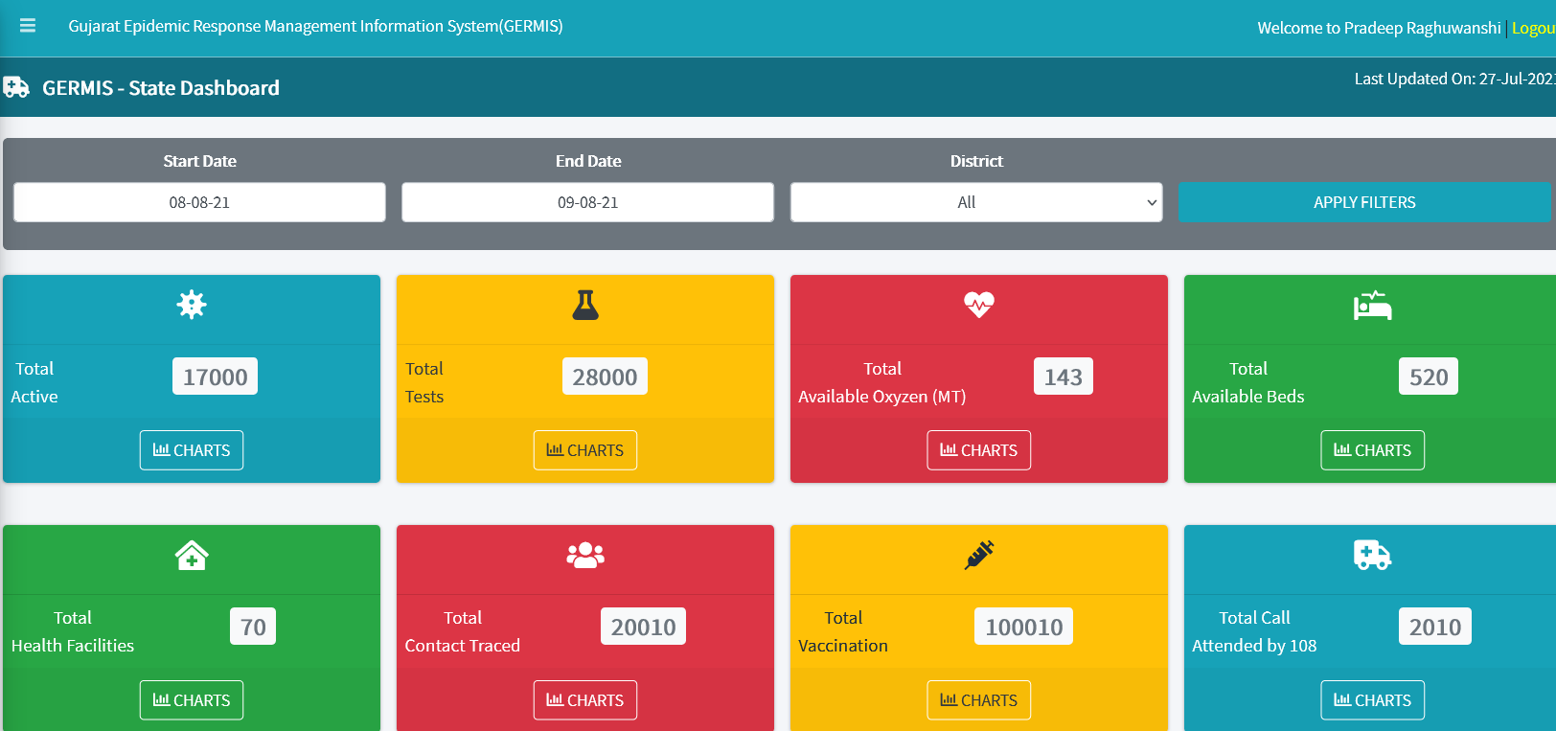

We can check further dashboard after done login process. Dashboard represents the chart details of Hospitals, Facilities etc.

We can also see listed menu’s in Dashboard Main page.

There are below Listed Menu’s available in Dashboard.

1) Dashboard

2) Health Facility

3) Master Module

4) Oxygen Module

5) Public Health

6) Inventory Module

7) Maru Gaam Corona Mukt Gram

8) Reports

9) User Management

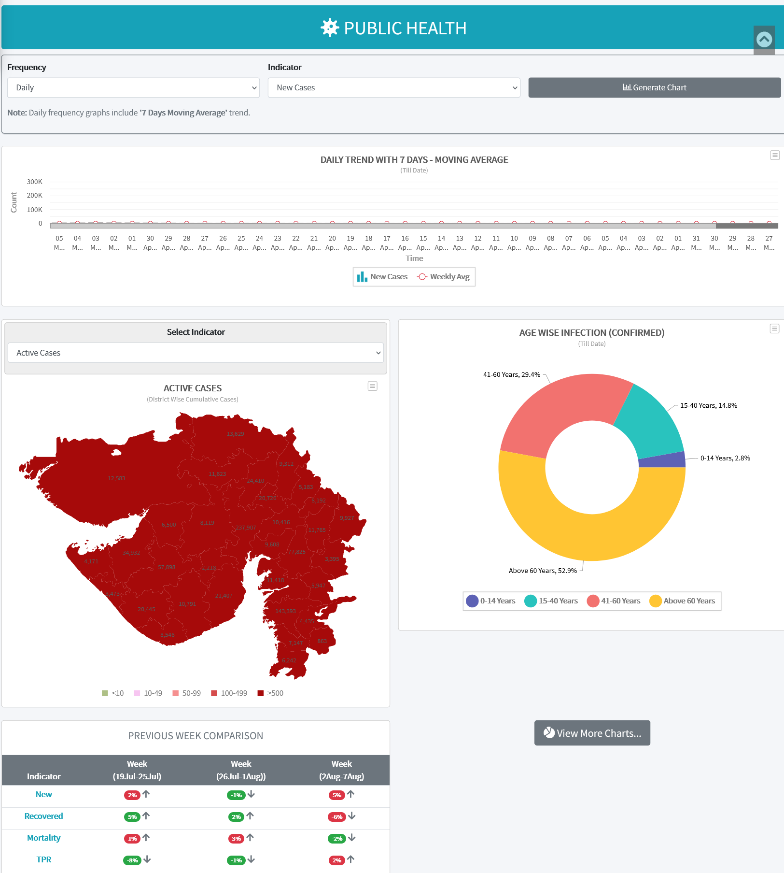

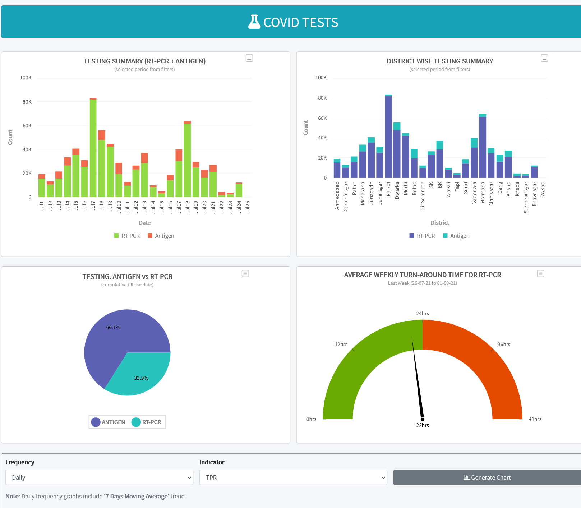

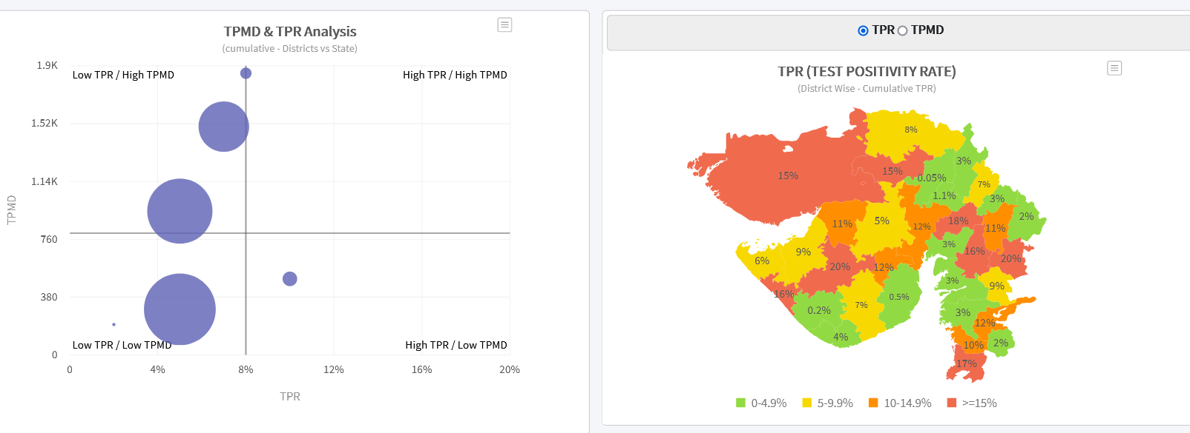



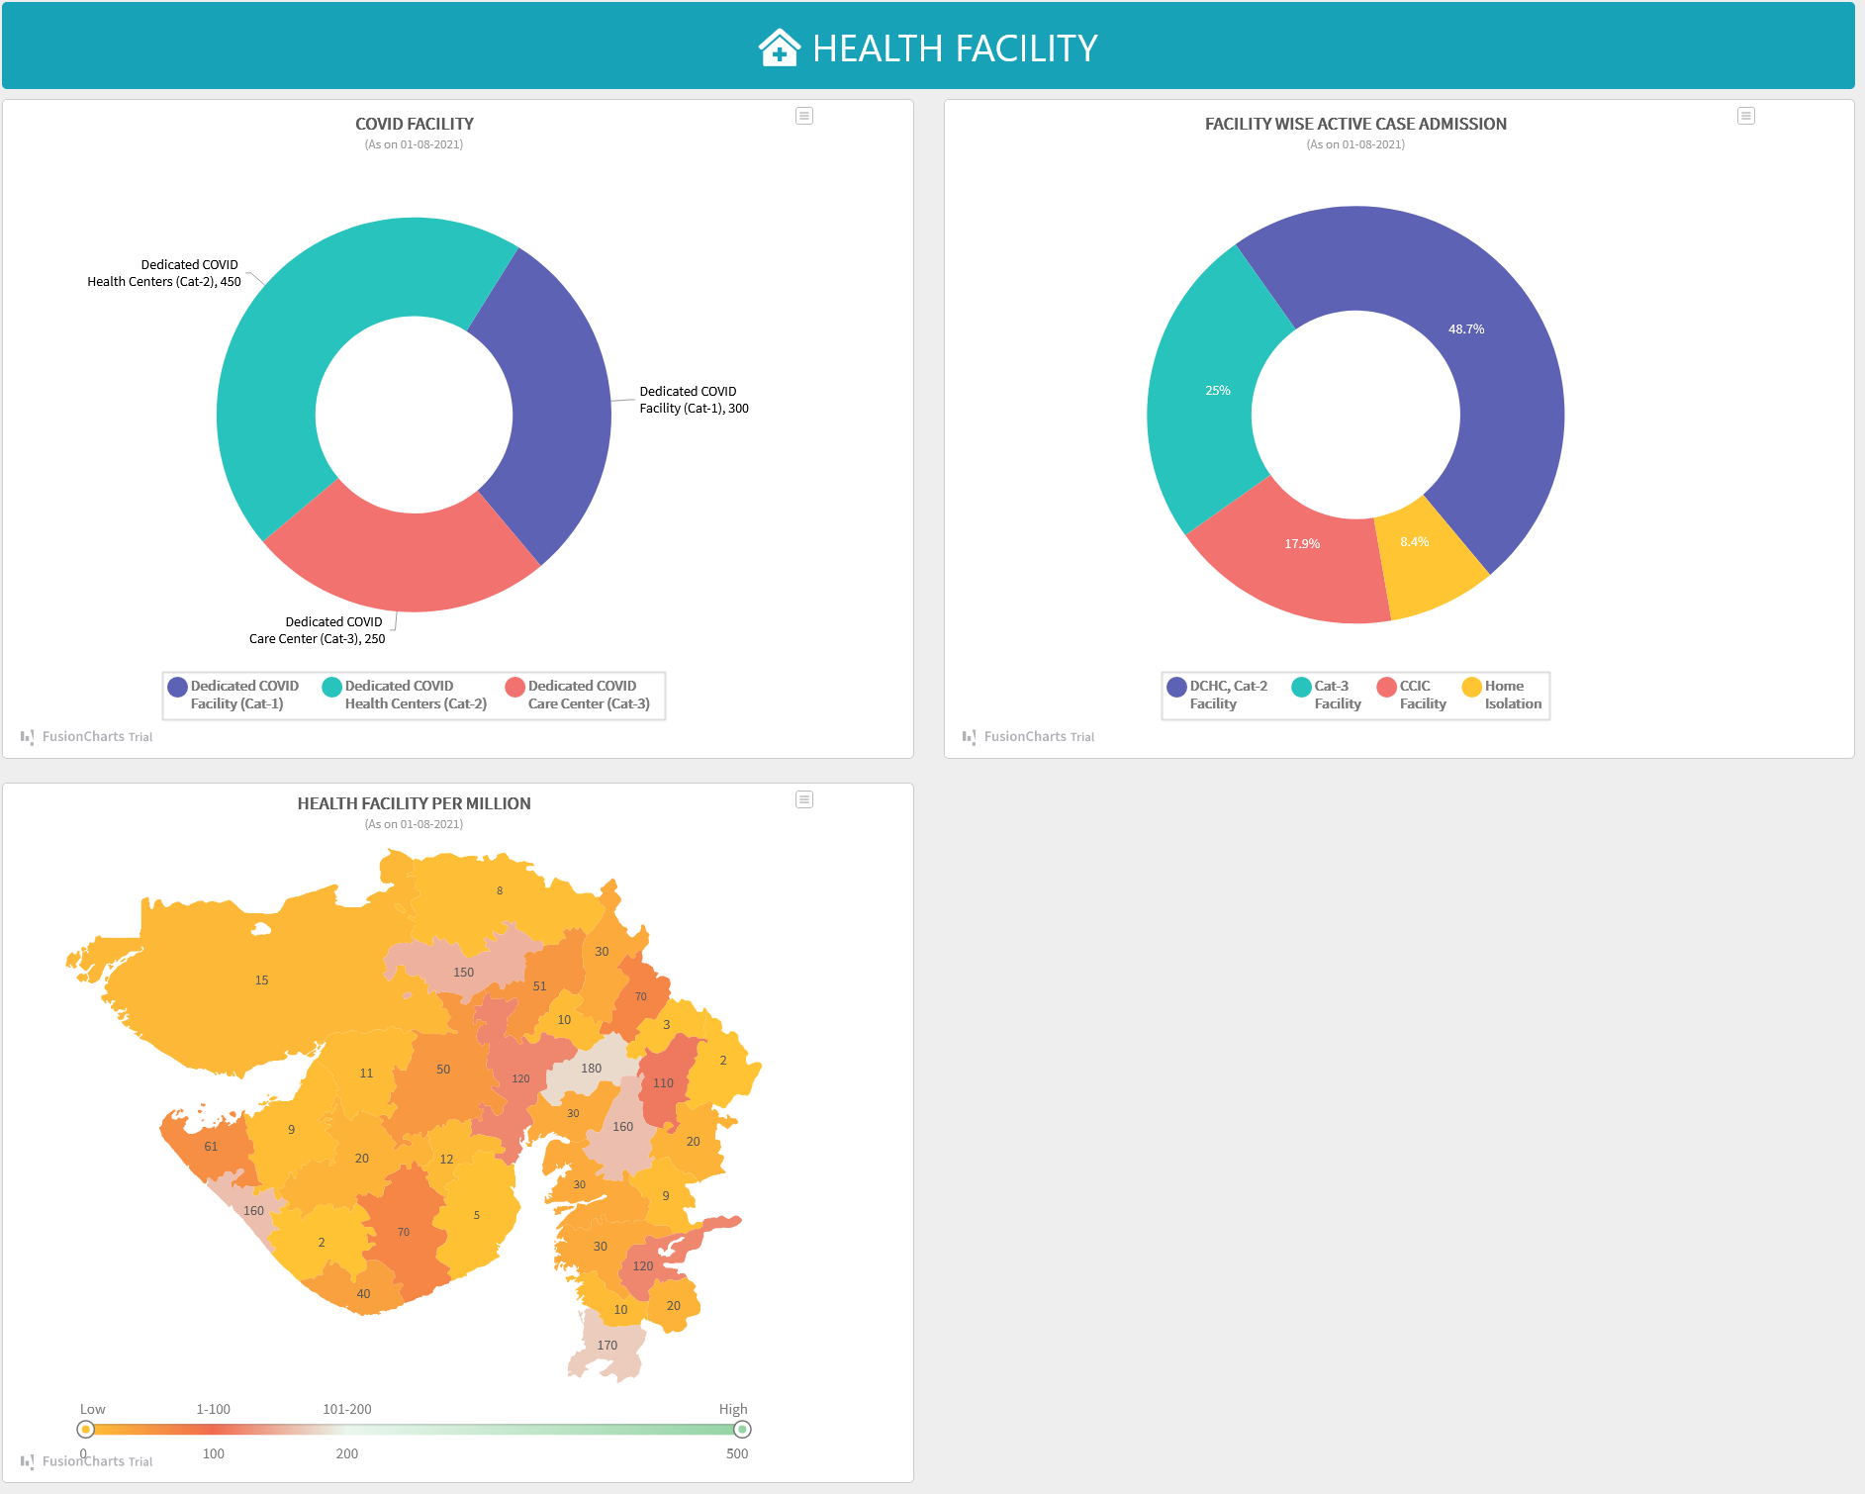



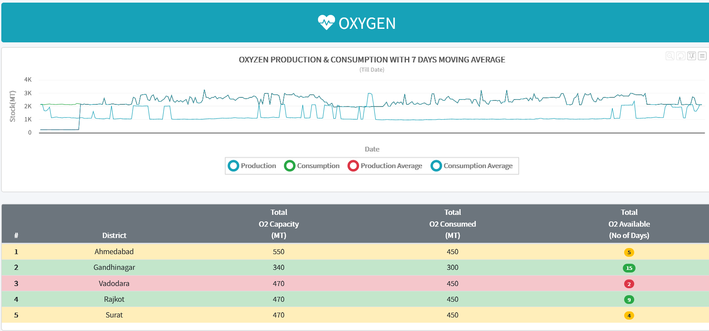

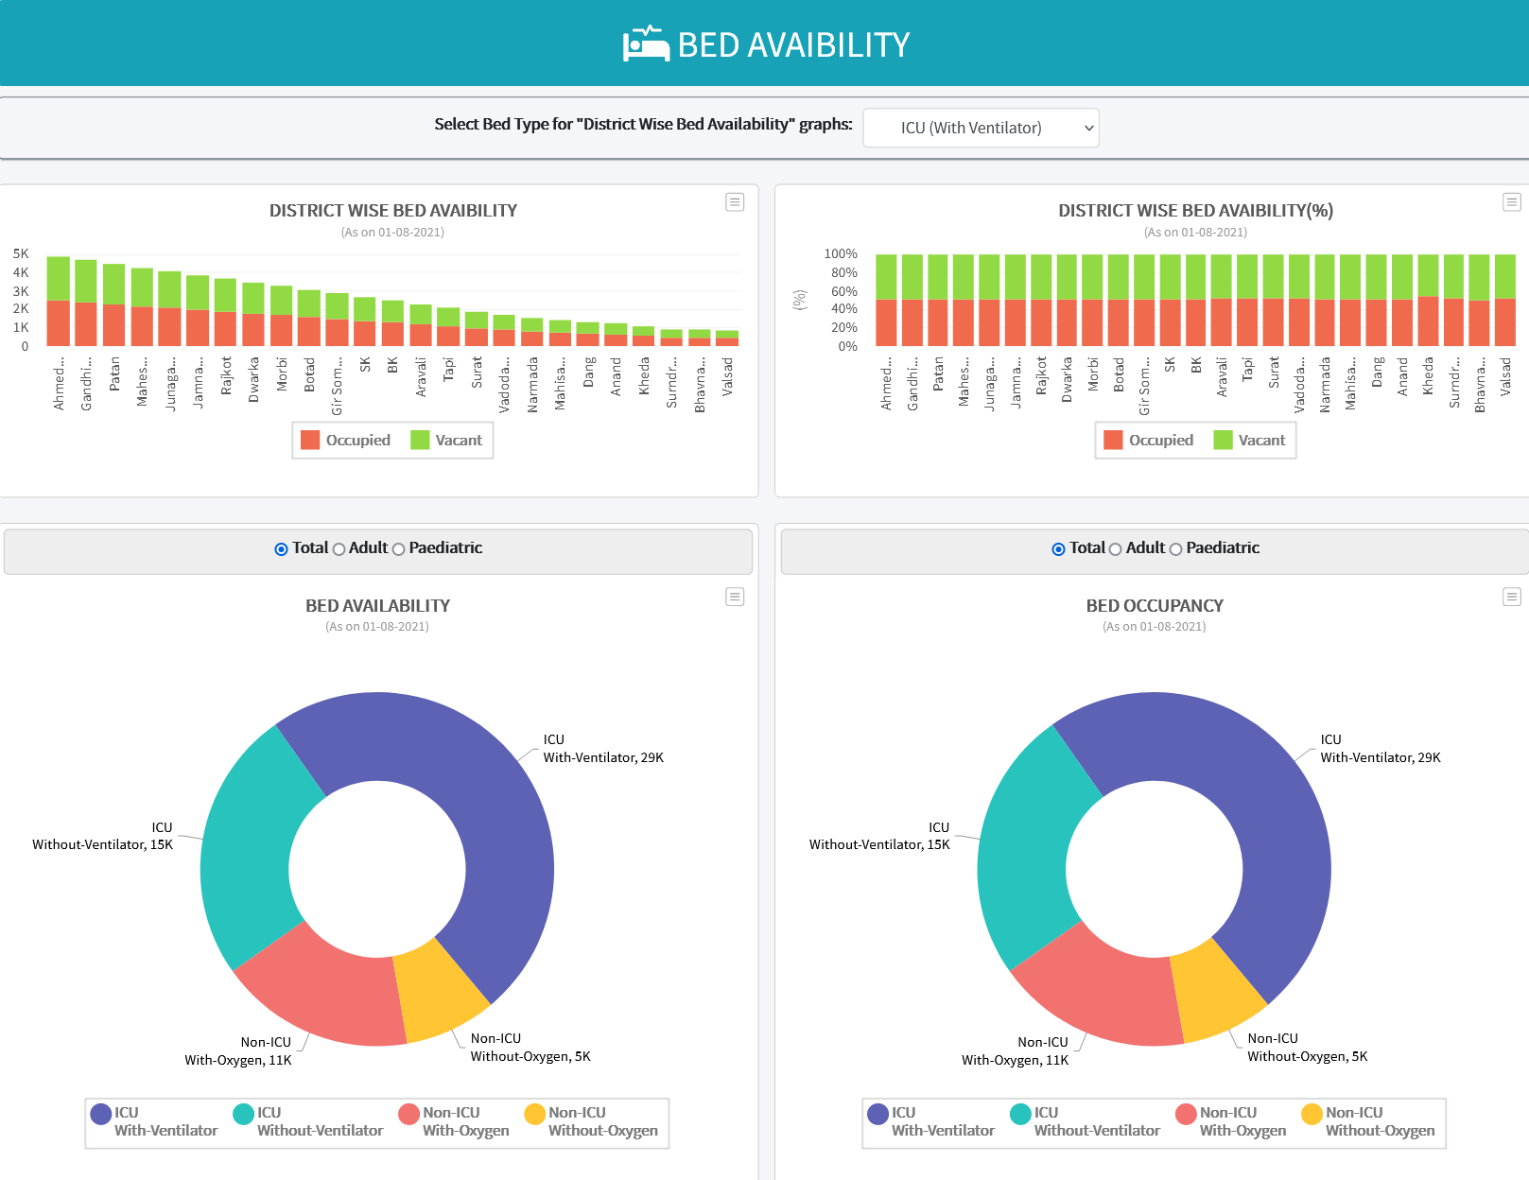



# User Management

* 1. User Group Menu (District Level Entry)

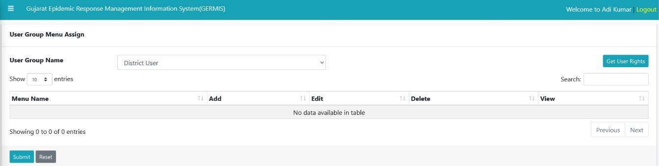

We can see listed group of users for this system from dropdown (User group Name). We have district. Inventory, state and Hospital level user’s available in group. We can add and remove rights from particular group after clicking Get User rights for particular form.

* 1. Users (District Level Entry)

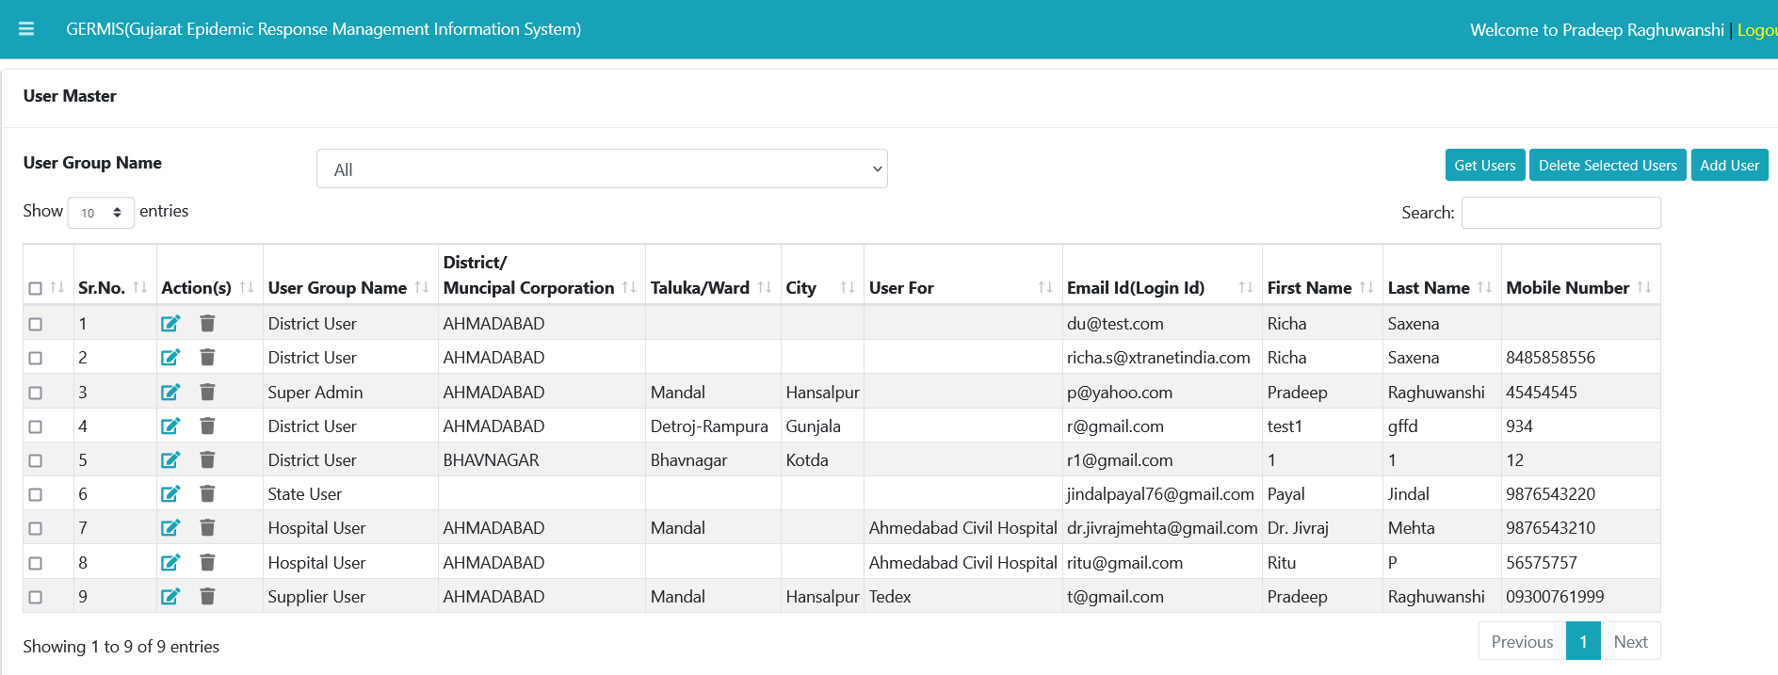



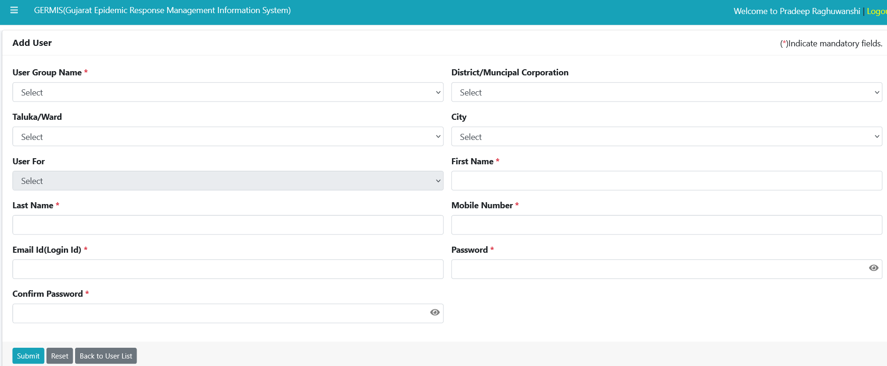

We can add new user using above user Master module. We need to click on Add new user button on User Master Module. We can also get list of created users in our system.

3.3) Change password (State level Entry)

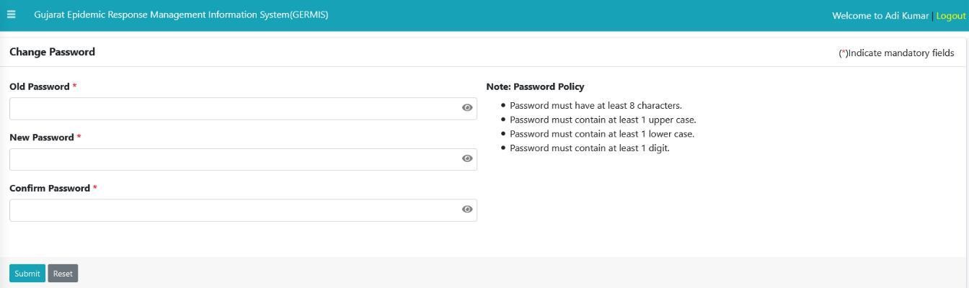

We can change password using above module. Make sure to fulfil password criteria before changing it.



3.4) Reset Password (State Level Entry)

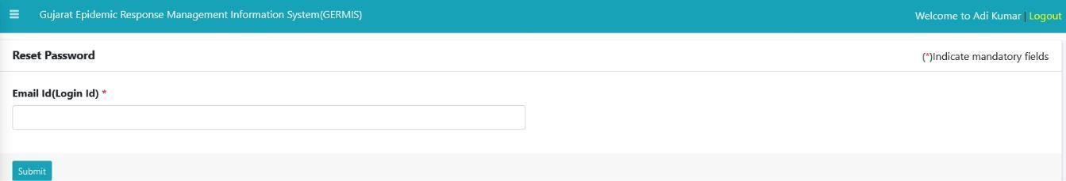

We can reset password using above module. We need to enter correct Email id for reset. Please make sure to click on link that you have received in your mail box.

* 1. Menus of GERMIS (State Level Entry)

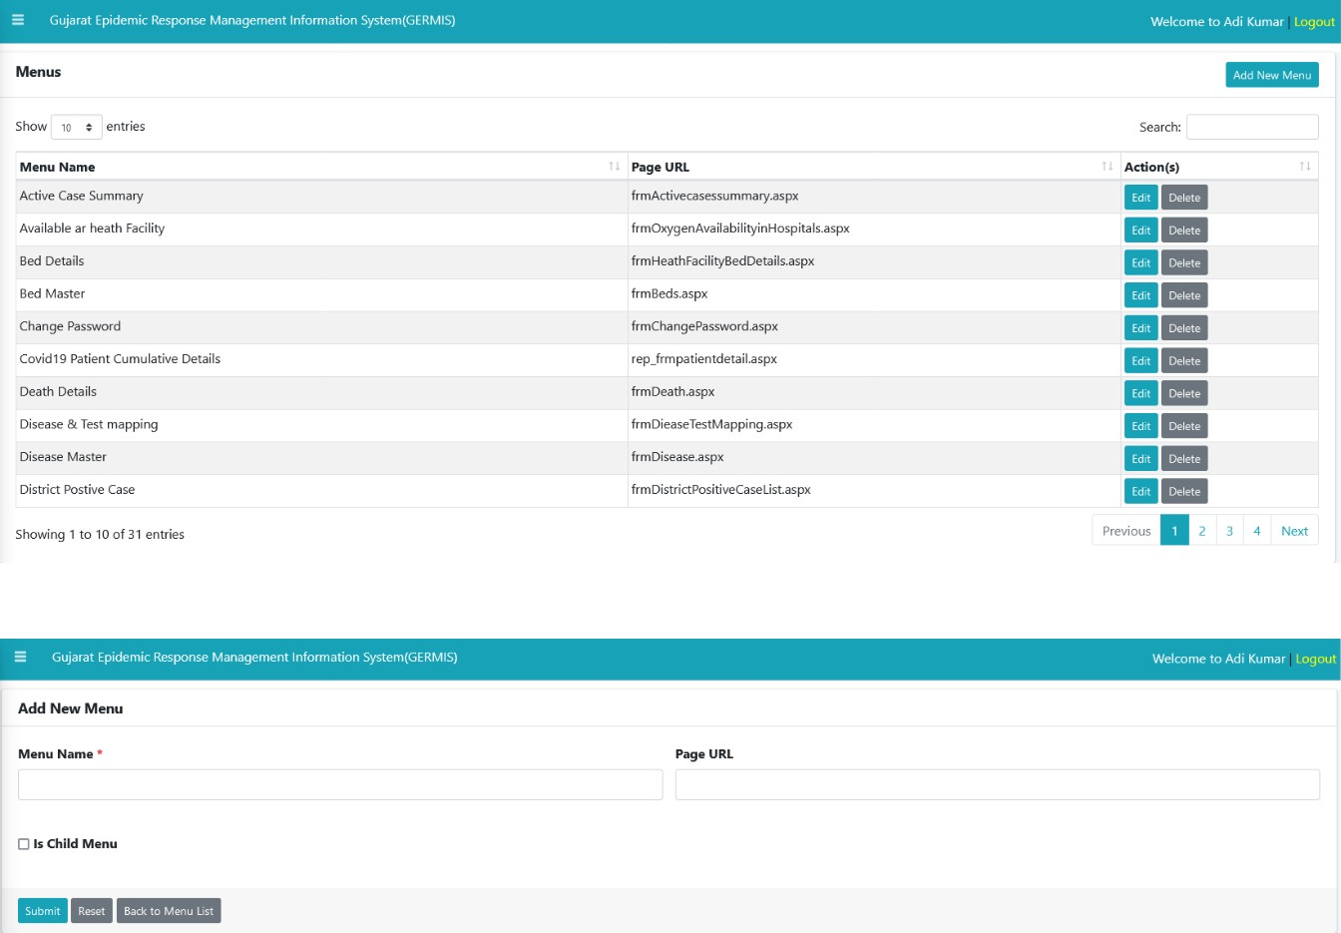

We can see list of Menu’s available in system. Also we can add new forms in particular menu bar in system.

# Master Module

* 1. Disease Master (State Level Entry)

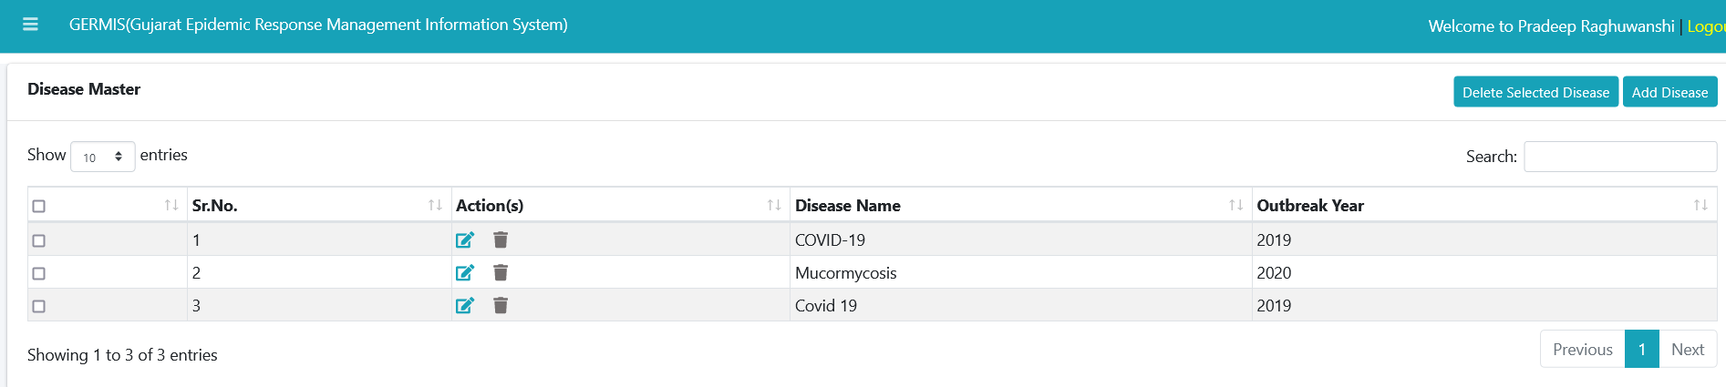

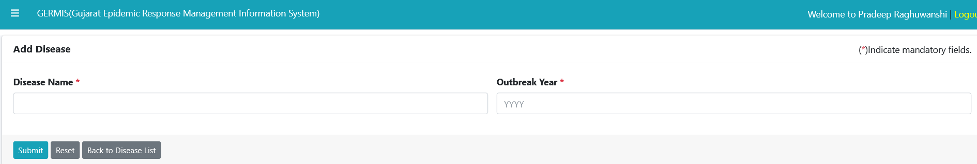

We can see listed disease available with outbreak year in system. We can also add new disease using above module to Master data with category type.

* 1. 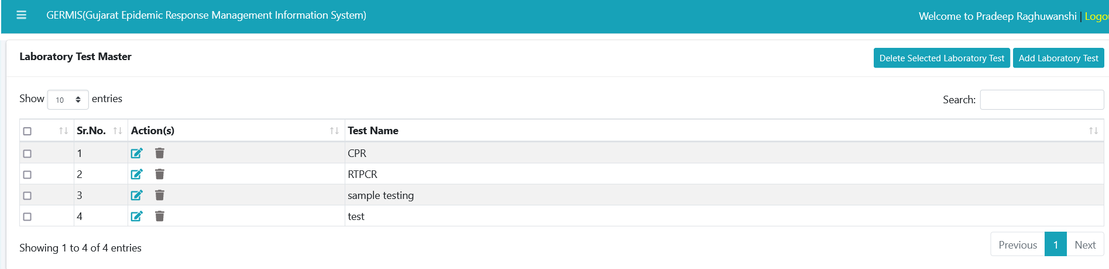Laboratory Test Master (State Level Entry)

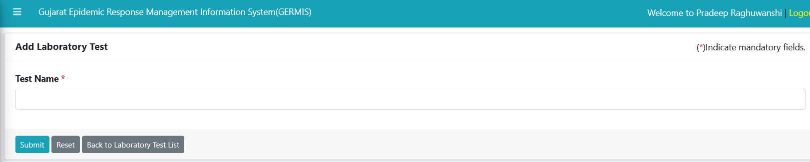

We can add new test using above module. We need to add test name if we required to add in future to master data.

We can also see the list of test available in system.

* 1. Unit Master (State Level Entry)

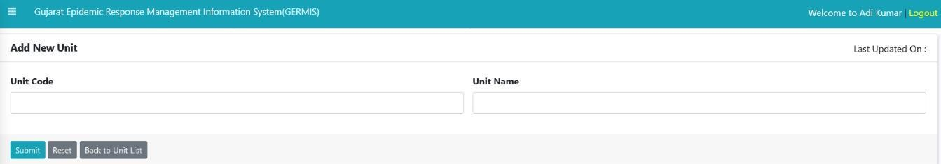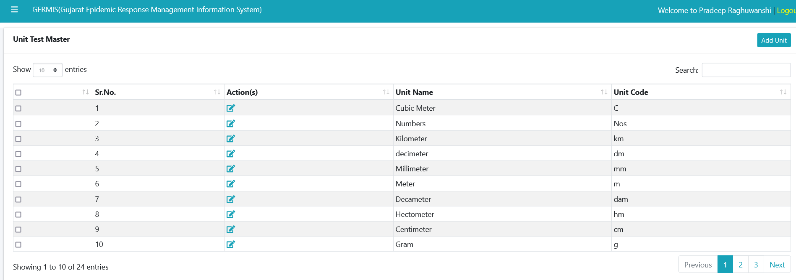

We can see listed unit’s available to measure equipment’s in system. This units are further

Map with medical equipment’s in inventory modules.

We can also add new Units in future to Master data.

* 1. Disease & Test Mapping (State Level Entry)

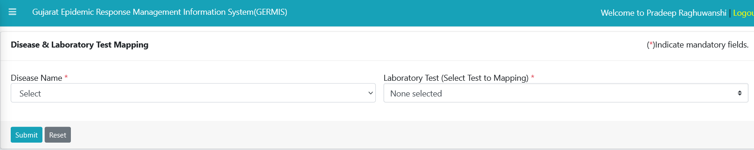

We can do mapping using above module for Disease name to Laboratory test list.

* 1. Facility & Disease Mapping (State Level Entry)

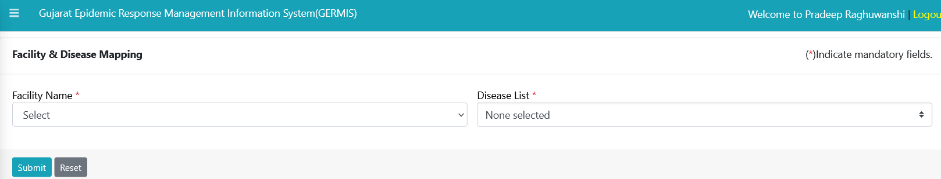

We can map disease list with hospital name. Its shows which type of recovery services from disease hospital provides.

We can bind multiple disease with one hospital.

4.9) Laboratory Master (State Level Entry)

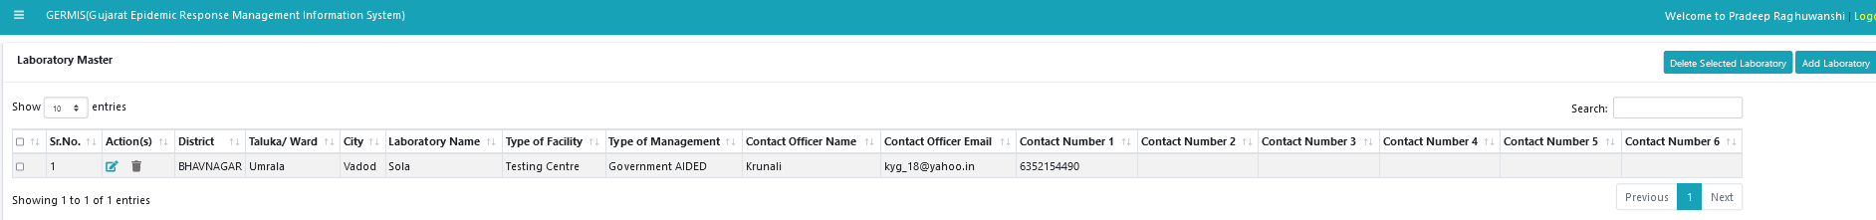

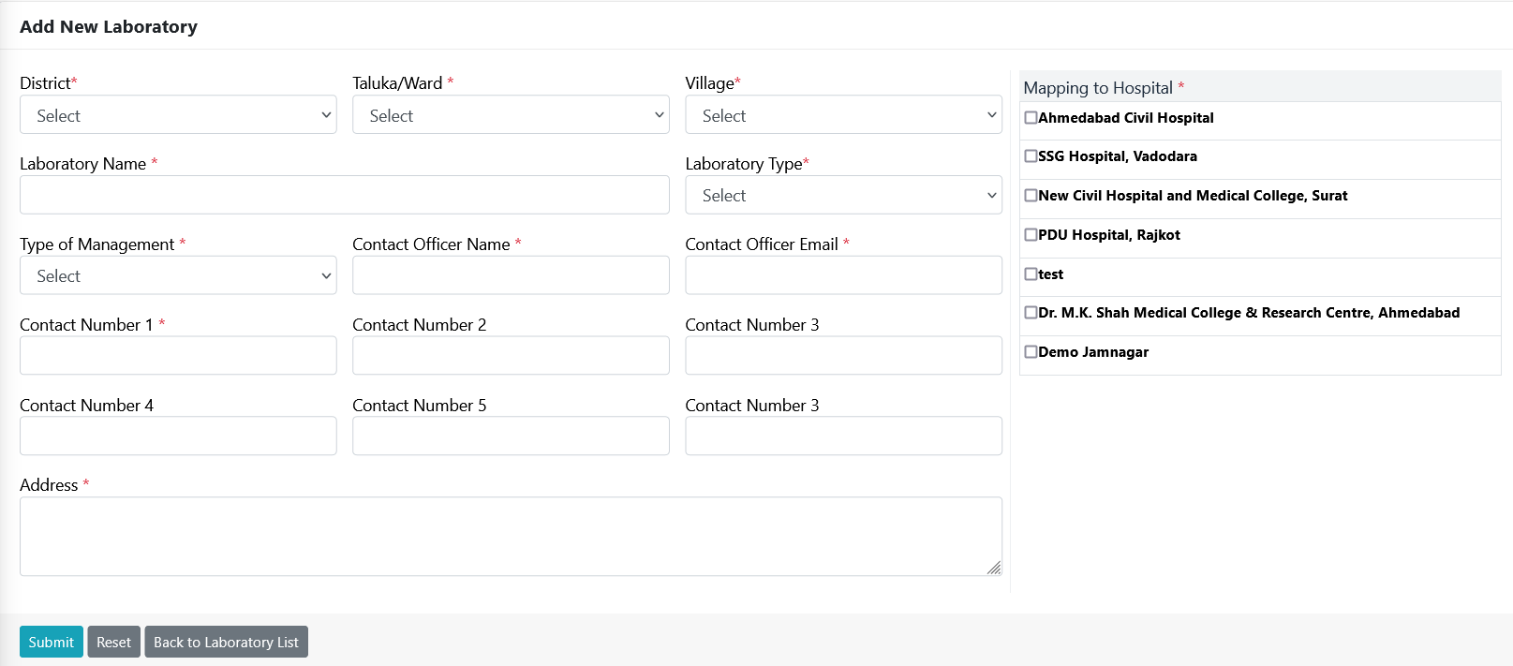

We can add new test name in particular laboratory in district using above module.

4.10) Testing Facility Mapping

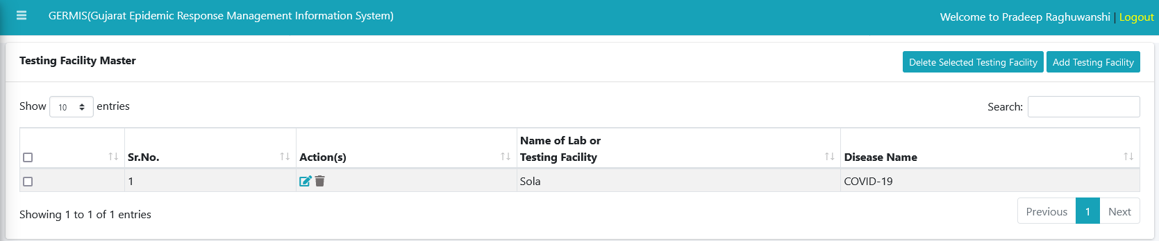

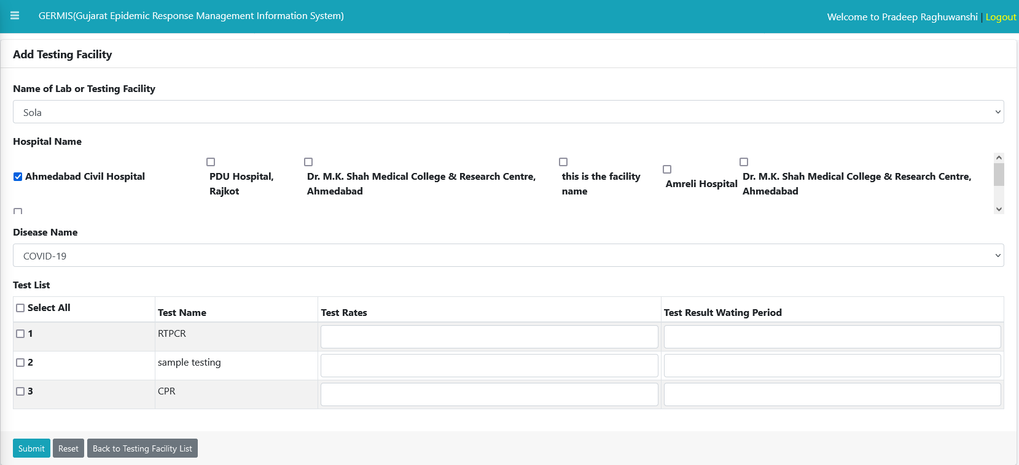

We can add Multiple Test for particular Hospital Facility using above module. Hospital must have laboratory facility available in this case.

# Health Facility

* 1. Health Facility Master (State/District Level Entry)

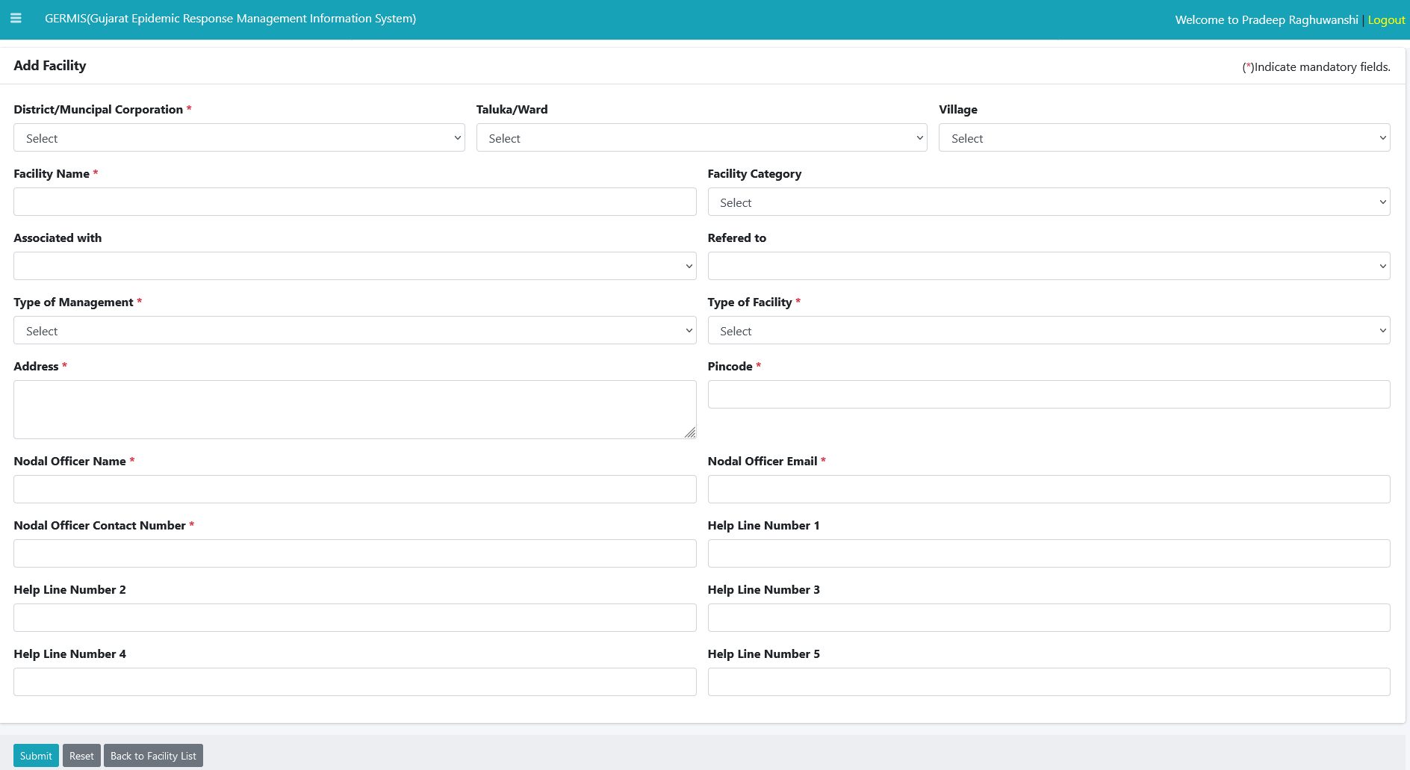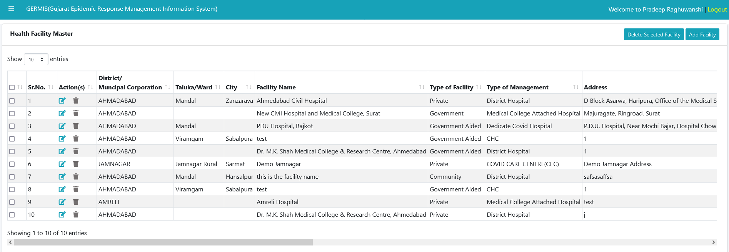

We can add new facility using above module for specific district. We can also see listed facility district wise using above module. Type of facility indicated type of hospital added for Covid care (GOVT/Pvt.).

* 1. Bed Master (Hospital Level Entry)

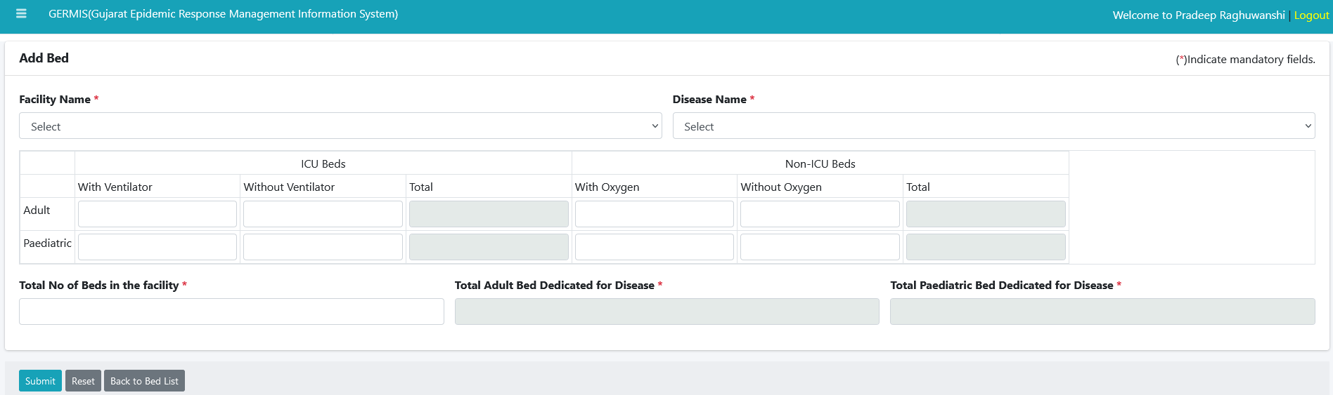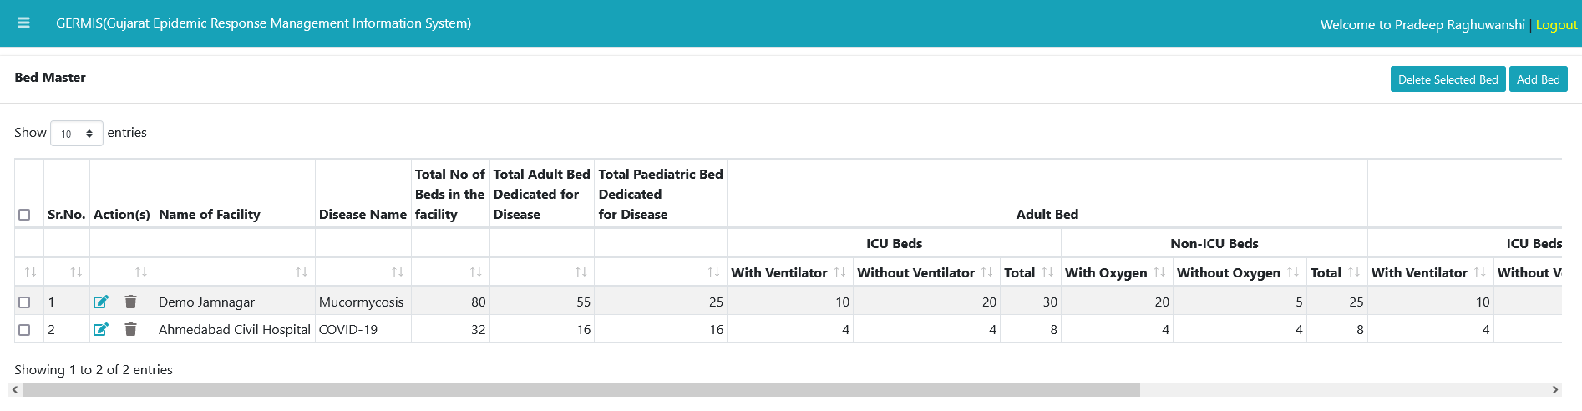

We can see listed beds available in each hospital allocated for Covid care center. We can also check how many beds available for Adult/Pediatric. Total beds available with Oxygen/without oxygen using above module. We can also add new beds for specific category such as Adult/Pediatric (with oxygen/without oxygen).

* 1. 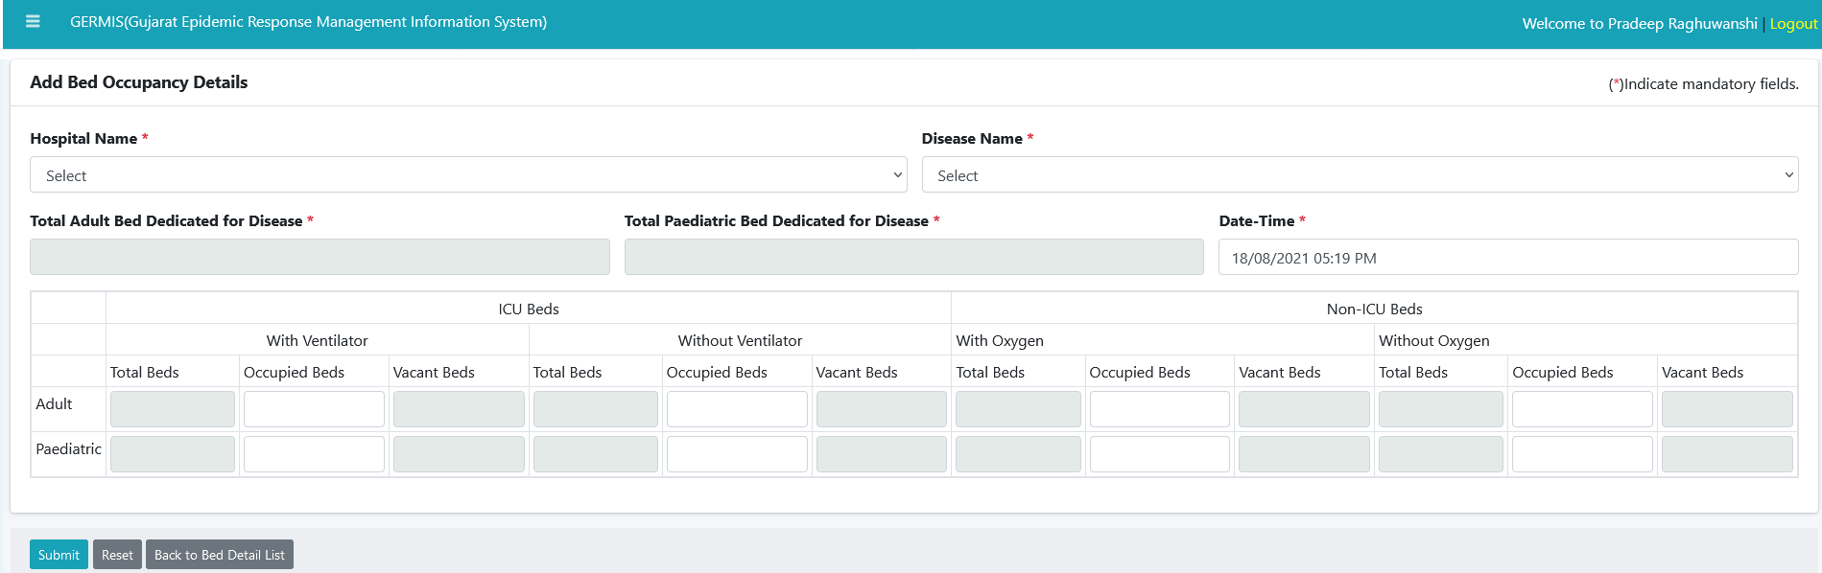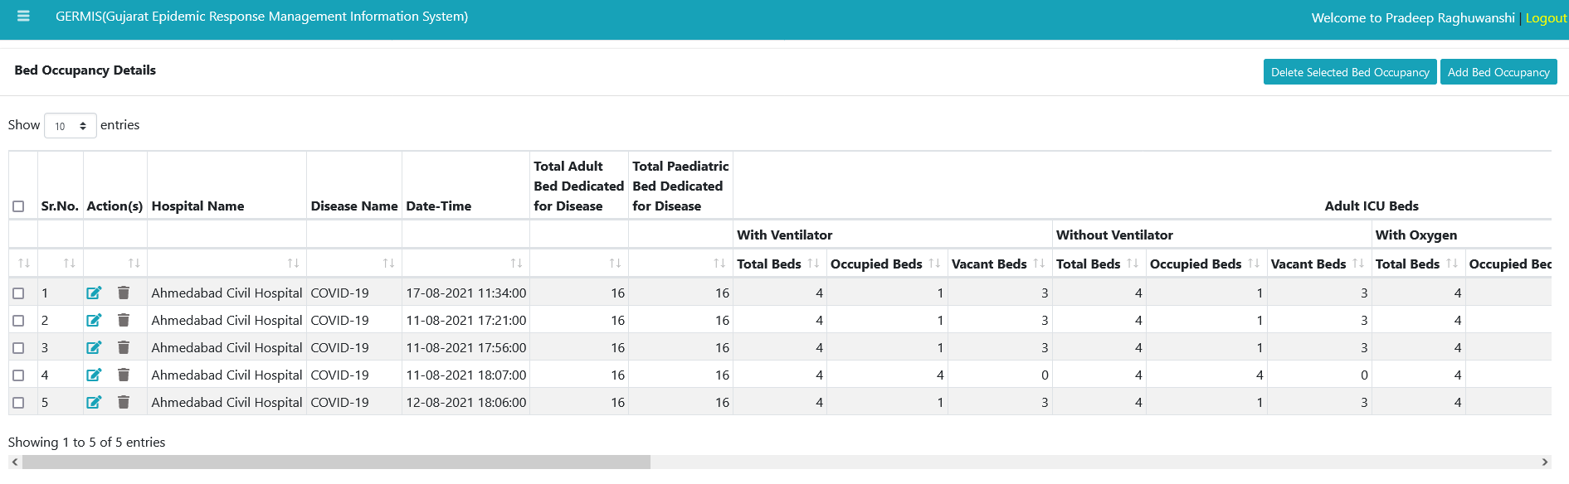Bed Occupancy Details (Hospital Level Entry)

We can see listed beds with its details such as occupied beds/Vacant beds under oxygen facility or without oxygen facility.

We can add details such as how many beds are occupied in specific hospital so we can get total vacant beds per hospital facility (Disease wise).

* 1. Oxygen Generation at health facility (Hospital Level Entry)

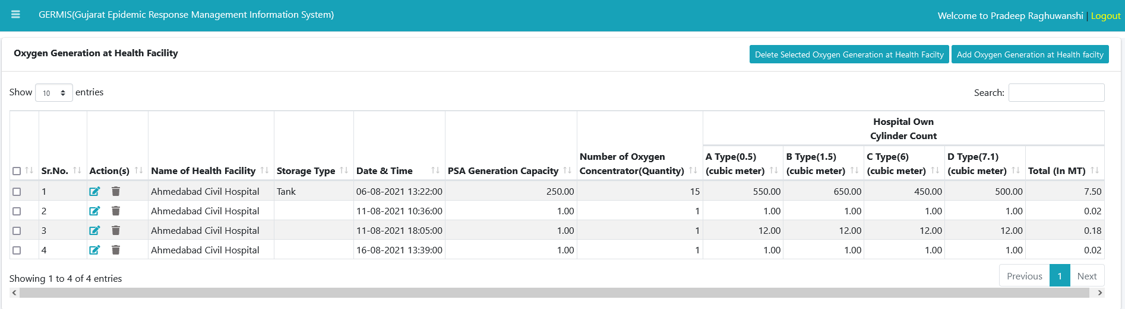

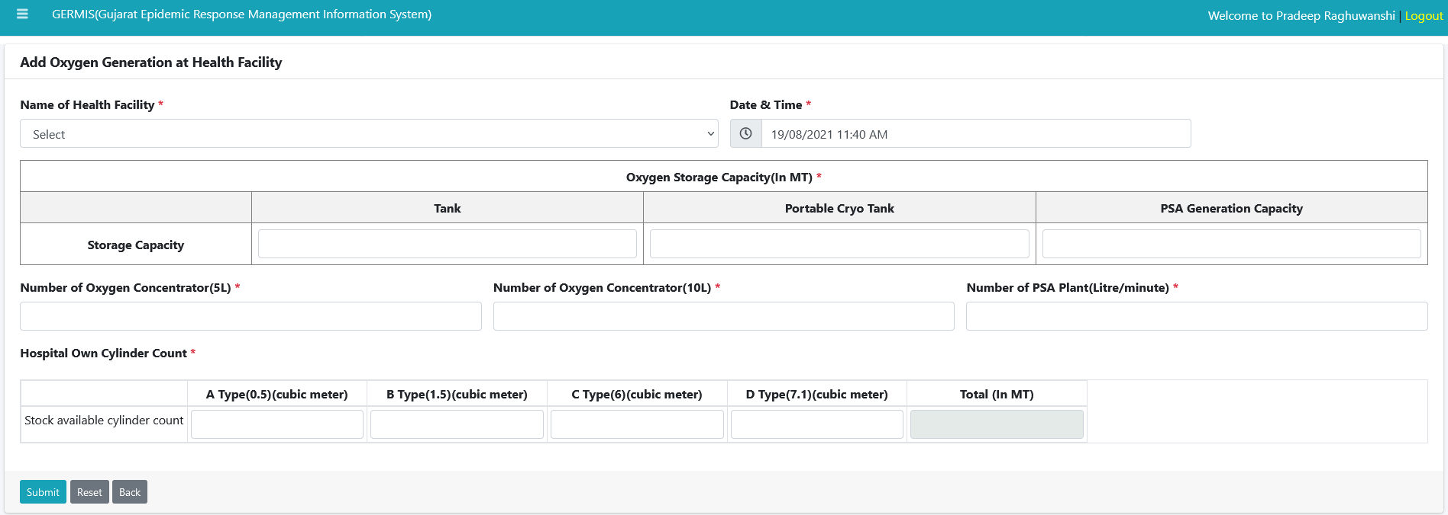We can check details about oxygen generation facility at hospital. It shows you how much one plant can generate and store oxygen in a day.

We can add details about oxygen generation facility at hospital using above module.

* 1. Oxygen Available at health Facility (Hospital Level Entry)

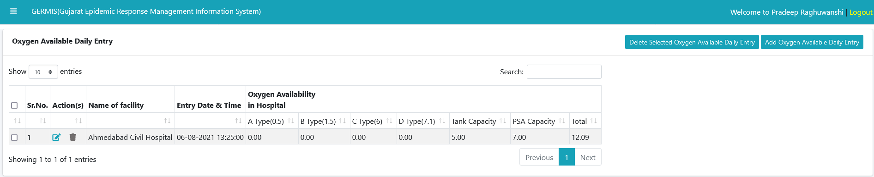

We can check list of oxygen cylinder available at hospital which was generated by PSA using above module.

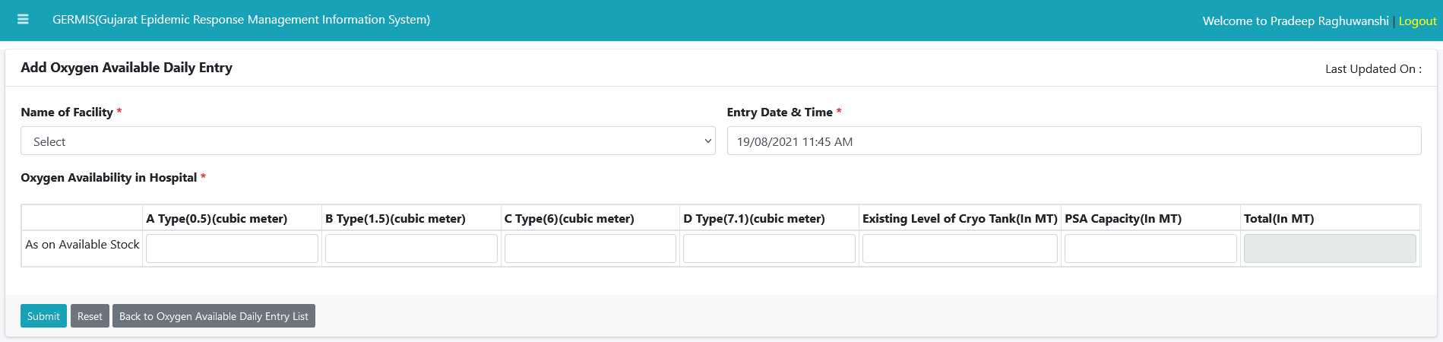

We can add details about availability of oxygen at hospital using above module.

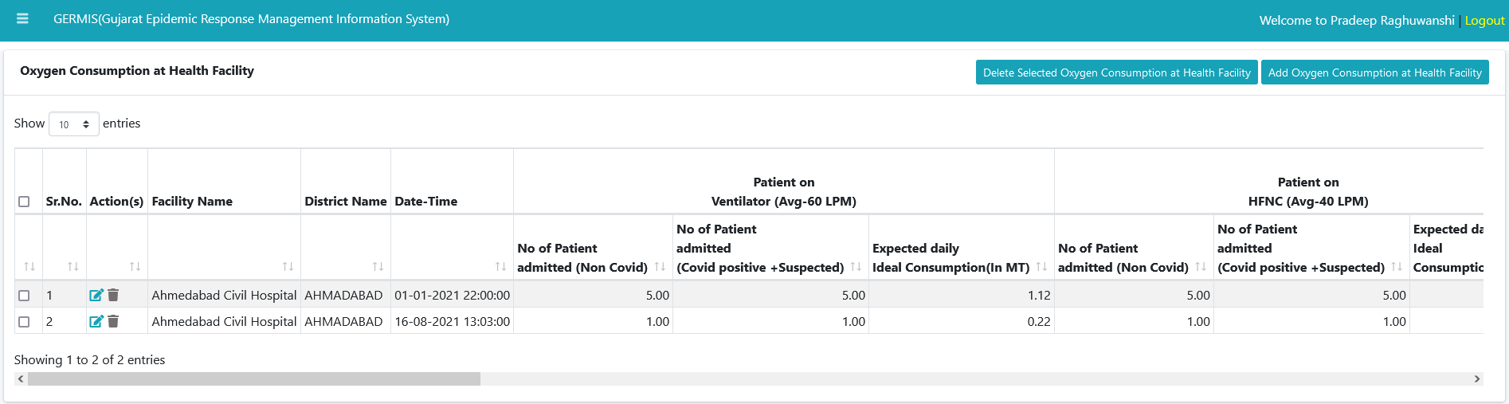5.9) Oxygen Consumption at Health Facility

We can check details about consumption of oxygen at specific health facility (Hospital). It also differentiate oxygen consumed based on patient with ventilator or with HFNC.

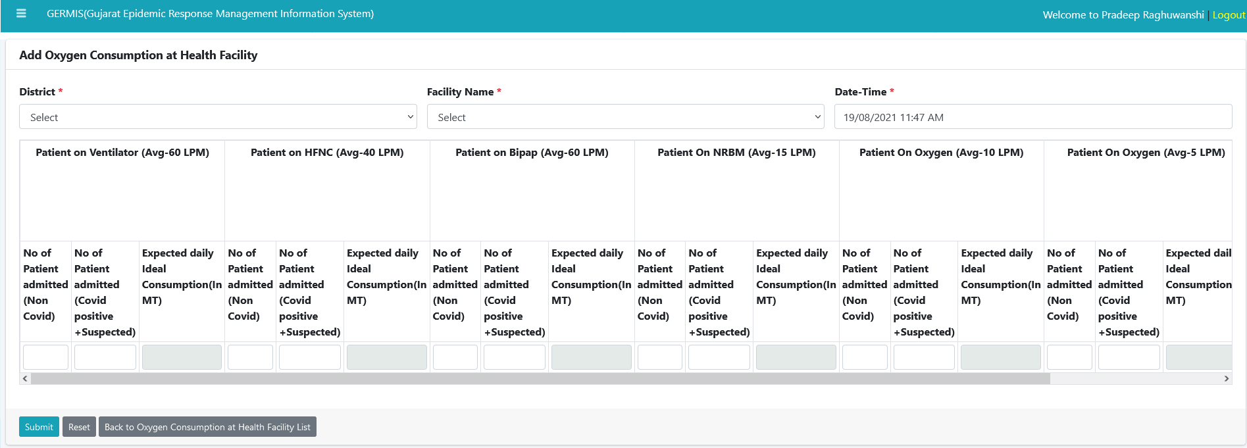

We can add those differentiate patient records using this above module. Records available for each hospital facility on As on Date.

1. Inventory
   1. Inventory Master (State Level Entry)

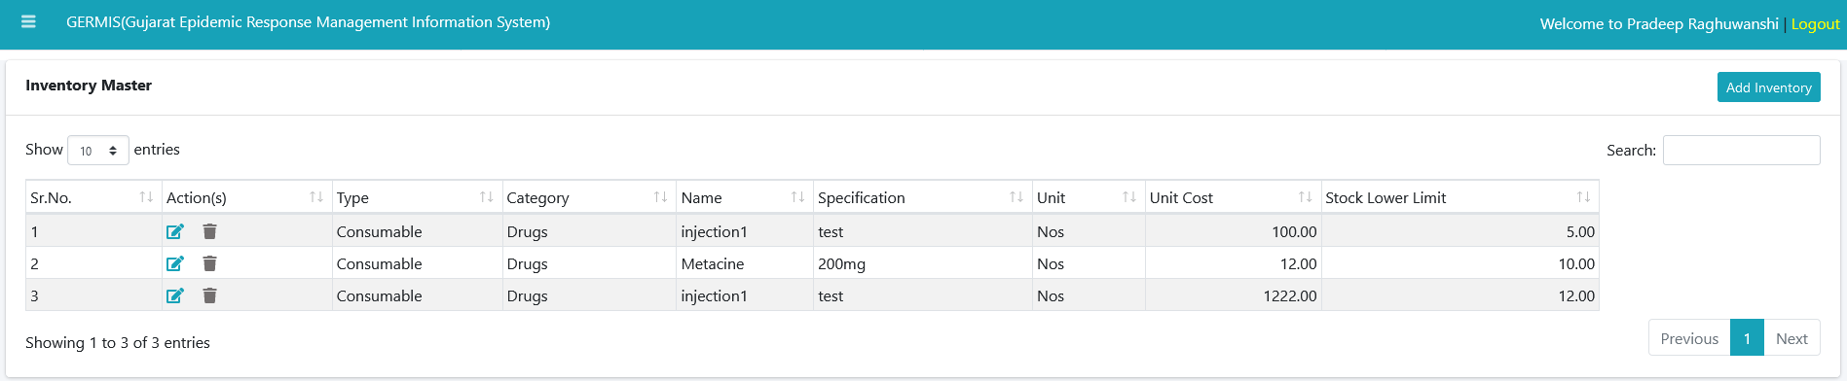

We can check list of inventory available of each category in Hospital facility using above module. Stock lower limit indicates we should have given minimum amount of stock need to take at least in hospital.

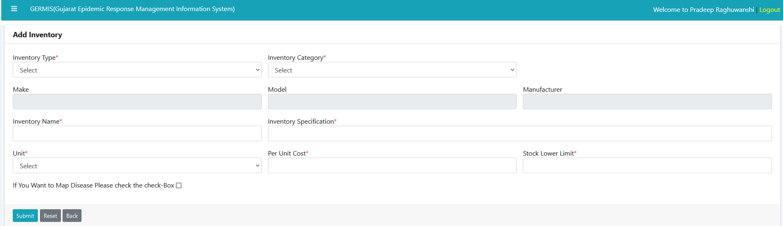

We can add new inventory in specific facility with its lower limit using above module.

* 1. Inventory Consumption (Hospital Level Entry)

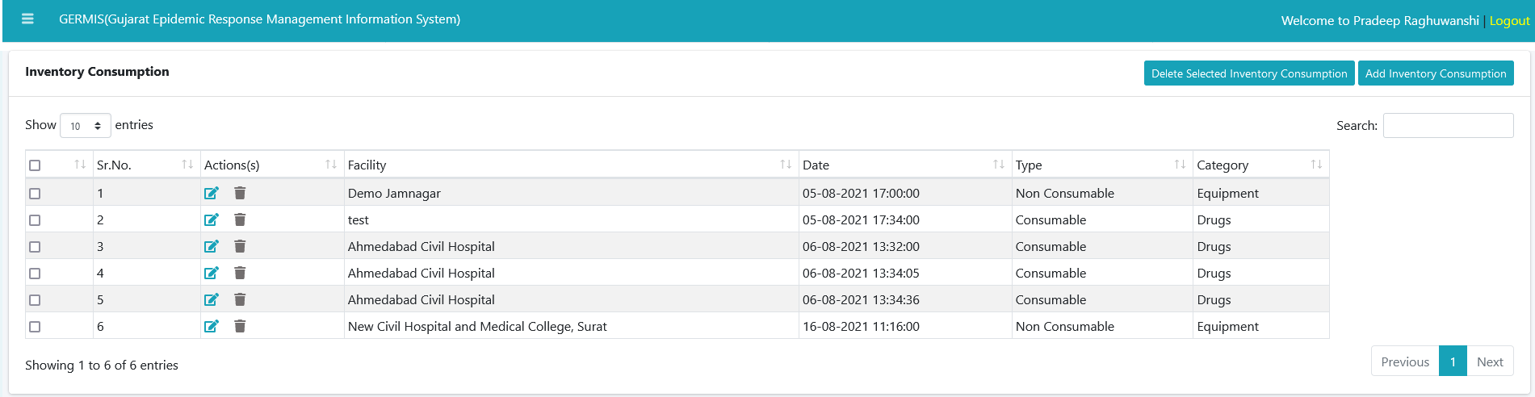

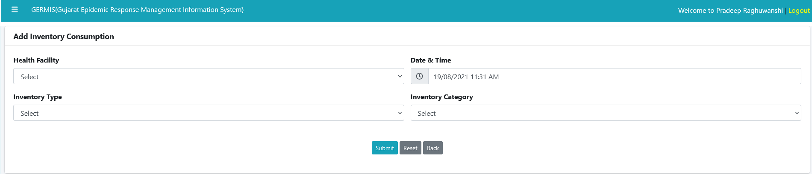

We can add and delete inventories using above module. Inventory should be within two types. 1) Consumable 2) Non Consumable

We can add new inventory using above module with specific category in hospital facility.

Inventory should be within above two types.

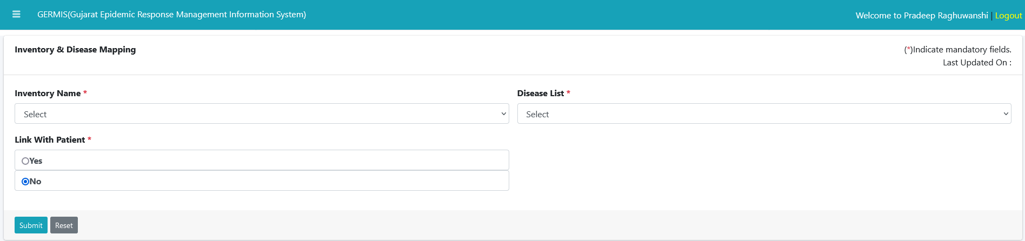 6.3) Disease Mapping (State Level Entry)

We can map Inventory and disease using above module. This specifies which one inventory allocated for specified disease.

1. Oxygen Module
   1. Oxygen Supplier/Manufacturer/ Trader Master (State Level Entry)

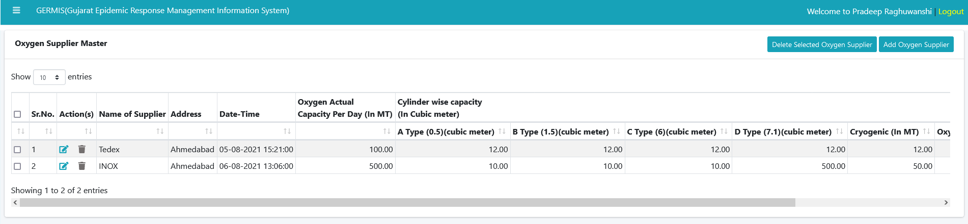

We can check Oxygen Supplier details using above module. We can also check cylinder types supplied by each supplier.

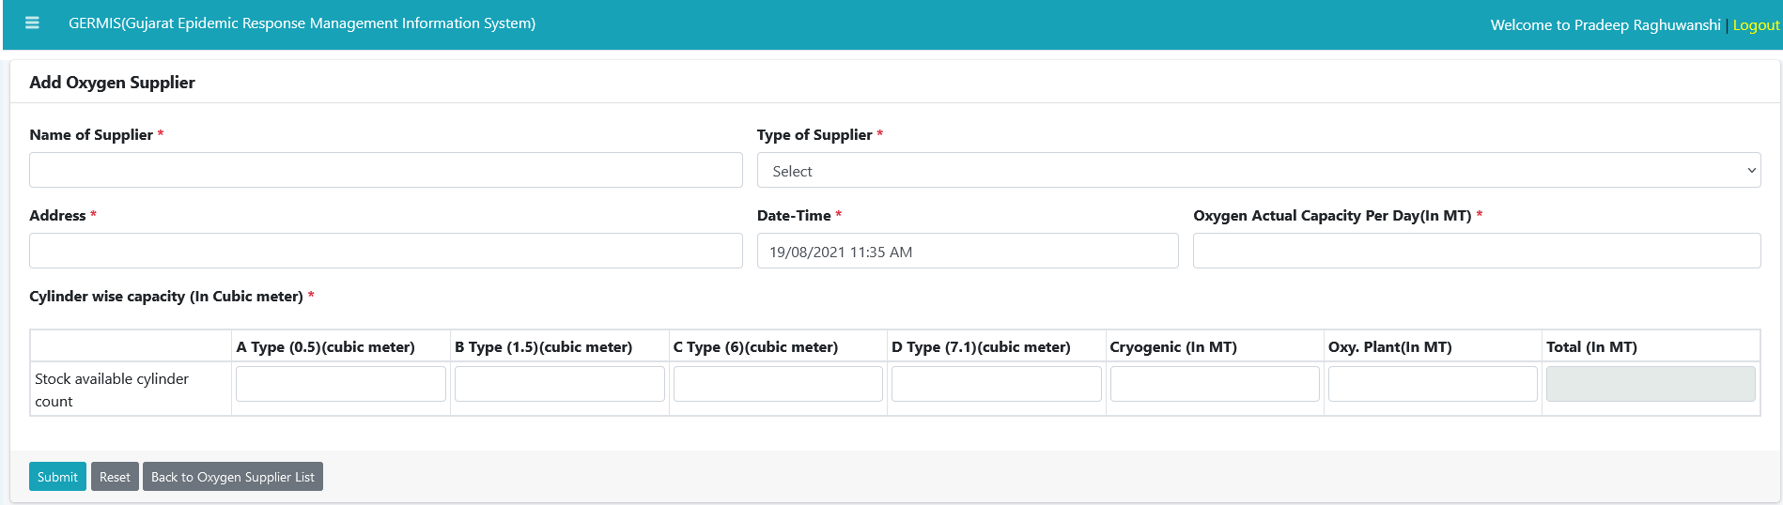

We can add new supplier using above module. We can also add types of cylinder with MT range supplied by each of them.

* 1. Oxygen Supply in Transit (State Level Entry)

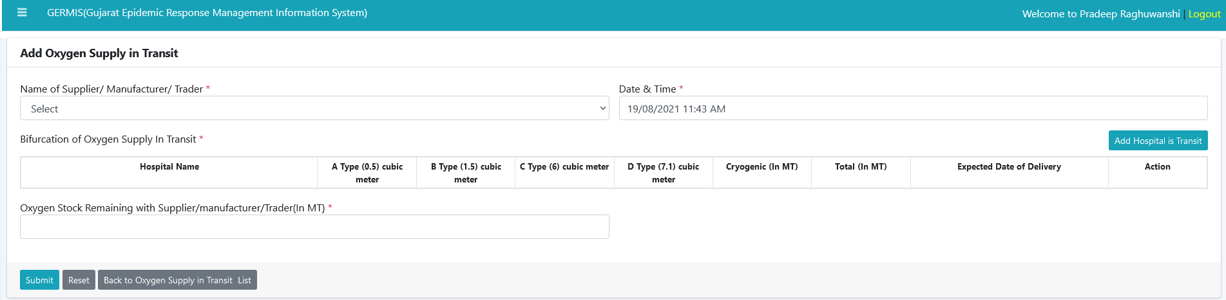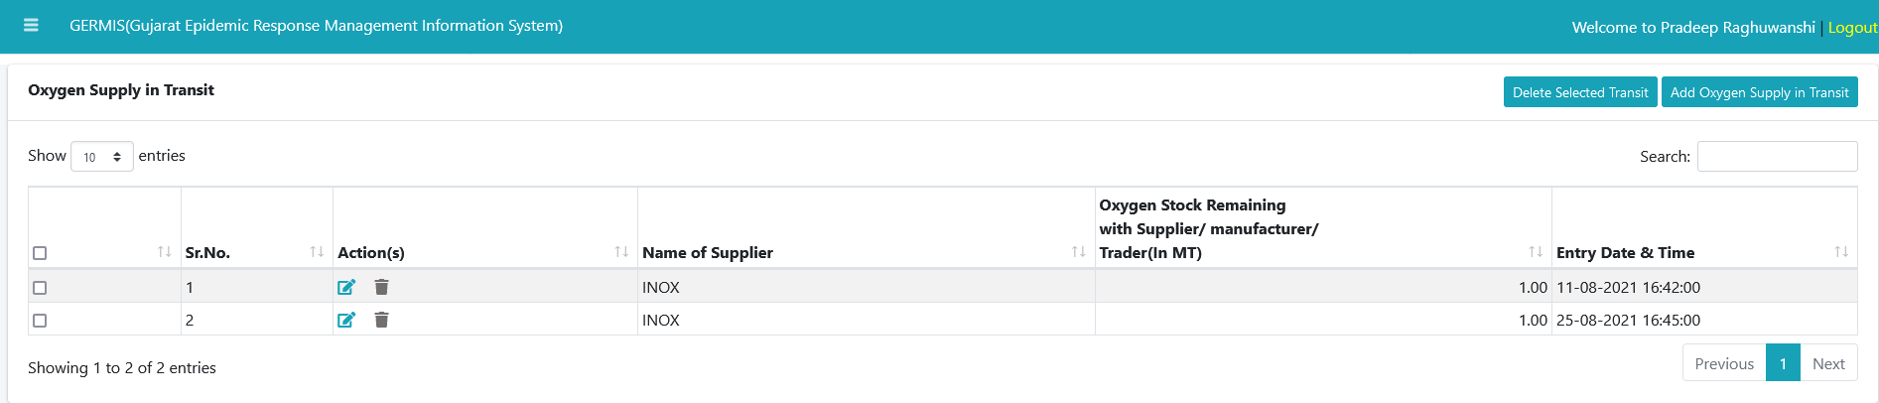

We can check stock status of Oxygen available in each hospital facility. It also shows stock status of various types of available cylinder.

We can add details about how much stock available for oxygen with various cylinder types supplied by supplier.

1. Public Health
   1. 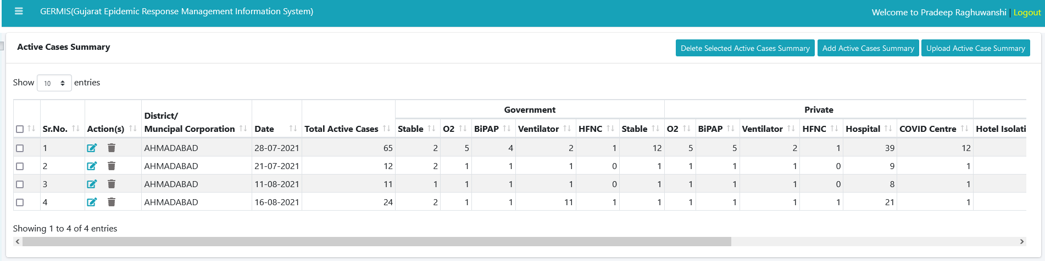Active Case Summary (District Level Entry)

We can check active case summary details using above module. We can also check how many cases are available under Covid treatment and without Covid treatment.

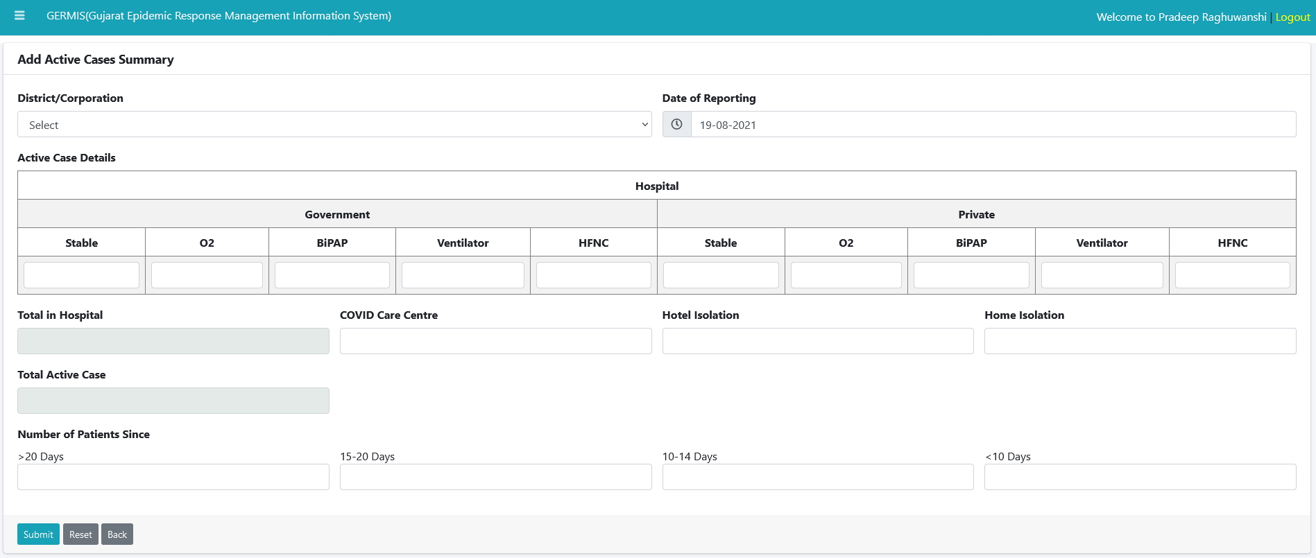

We can add details about cases available under GOVT/PVT hospitals. We can add details about covid patients whom are available under o2 or without o2.

* 1. Death Details (District Level Entry)

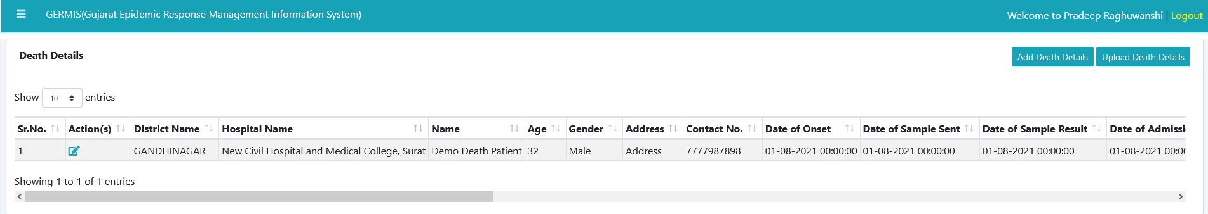

We can check death summary of patients using above module. We can filter it out number of patient death by Covid or other disease.

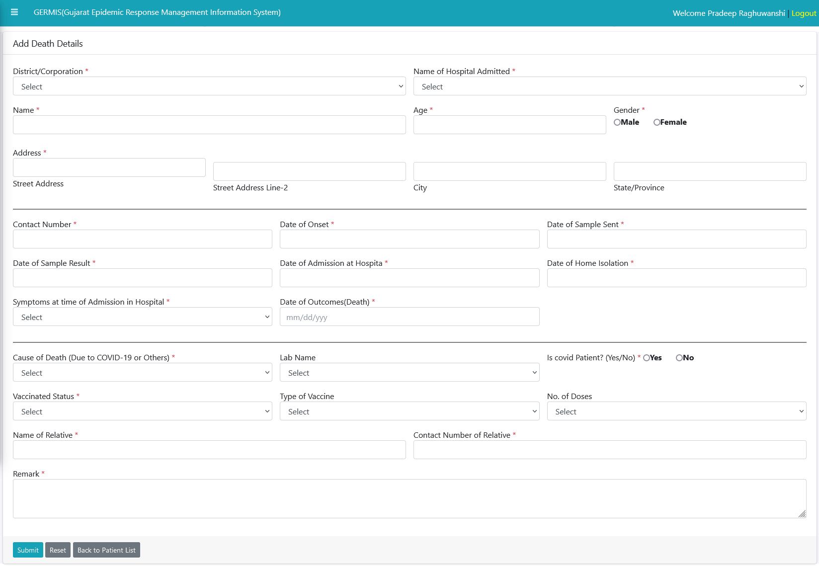

We can see add death details of any patient using above module.

* 1. District positive case (Laboratory Level Entry)

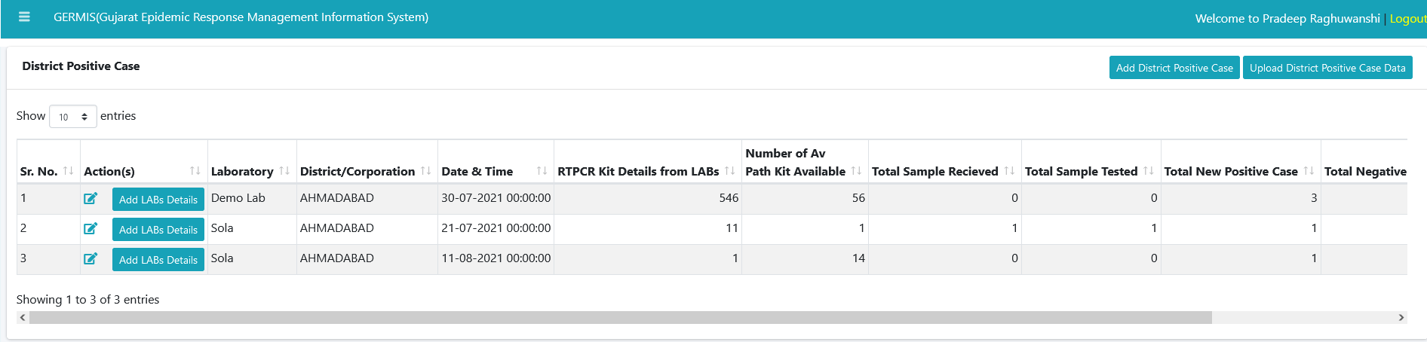

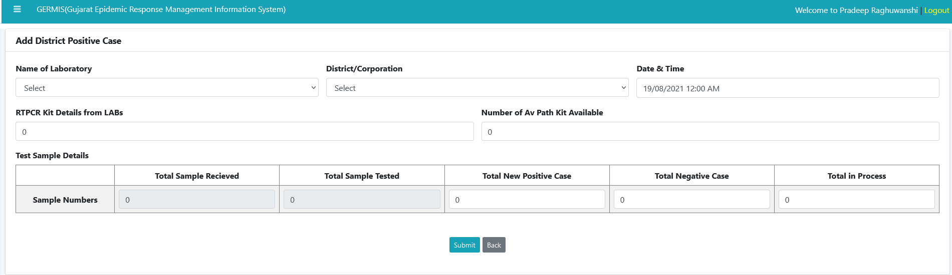We can check list of positive case available in one district using above list.

We can add district positive case details using above module. We can track cases available under which laboratory.

* 1. 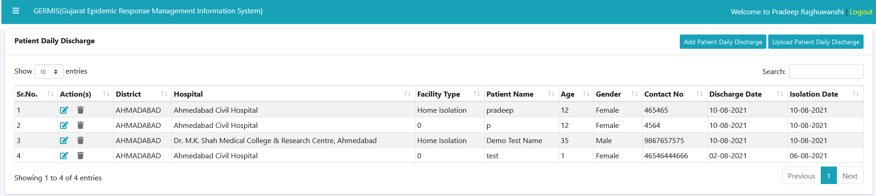Patient Daily Discharge (District Level Entry)

We can add discharge details of patients using above module.

* 1. Passenger Travel Data (Airport /Sea port Level Entry)

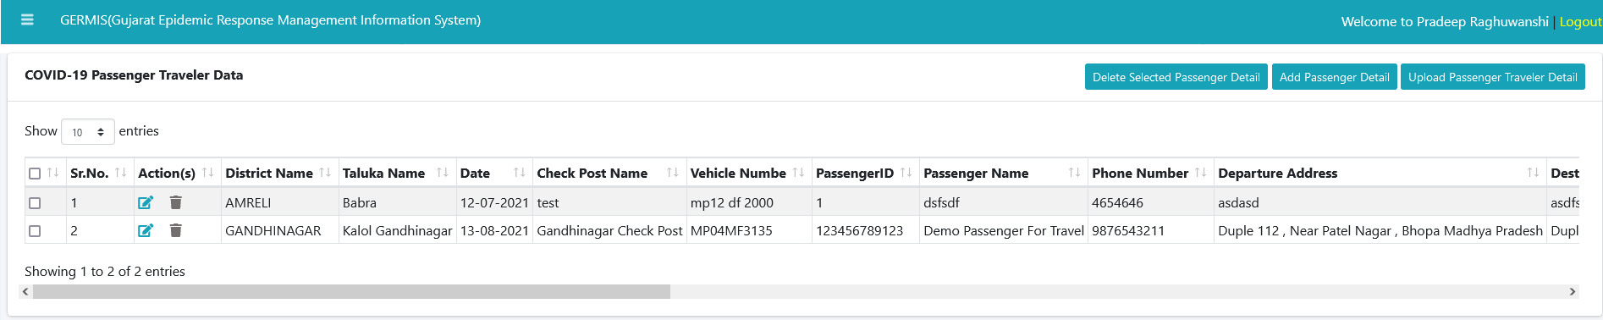

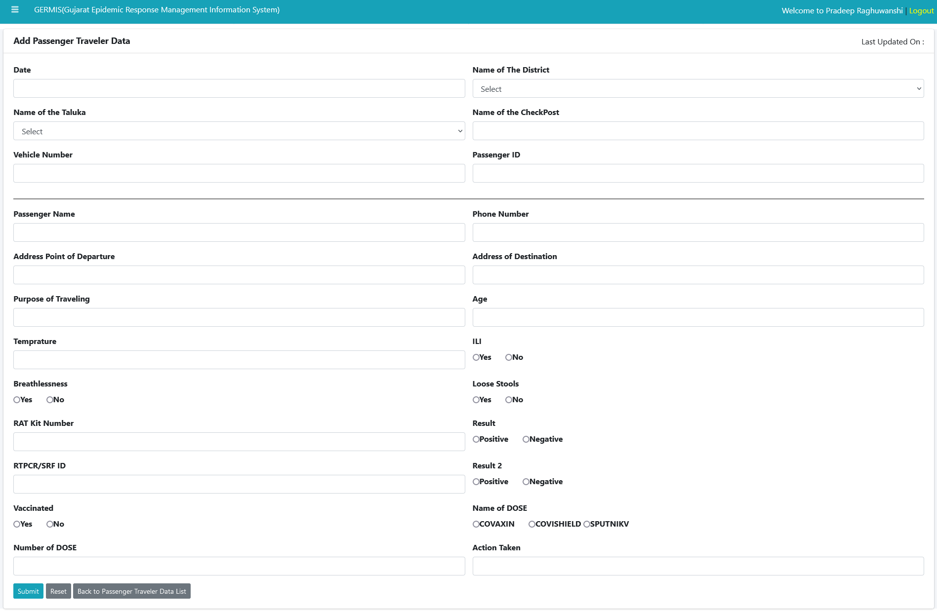We can see travelling details of passenger. Where they have travelled in intercity with Covid report.

We can add travelling details about passenger of intercity. We can also track vaccine doses taken by any passenger or whether they have done Covid test or not.

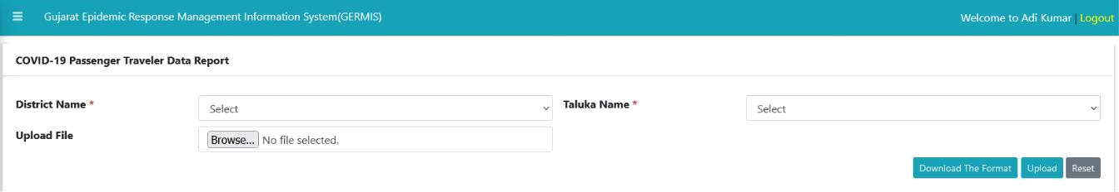

We can add travelled data report of passenger’s district wise.

* 1. Covid-19 Patient cumulative details (Laboratory Level Entry)

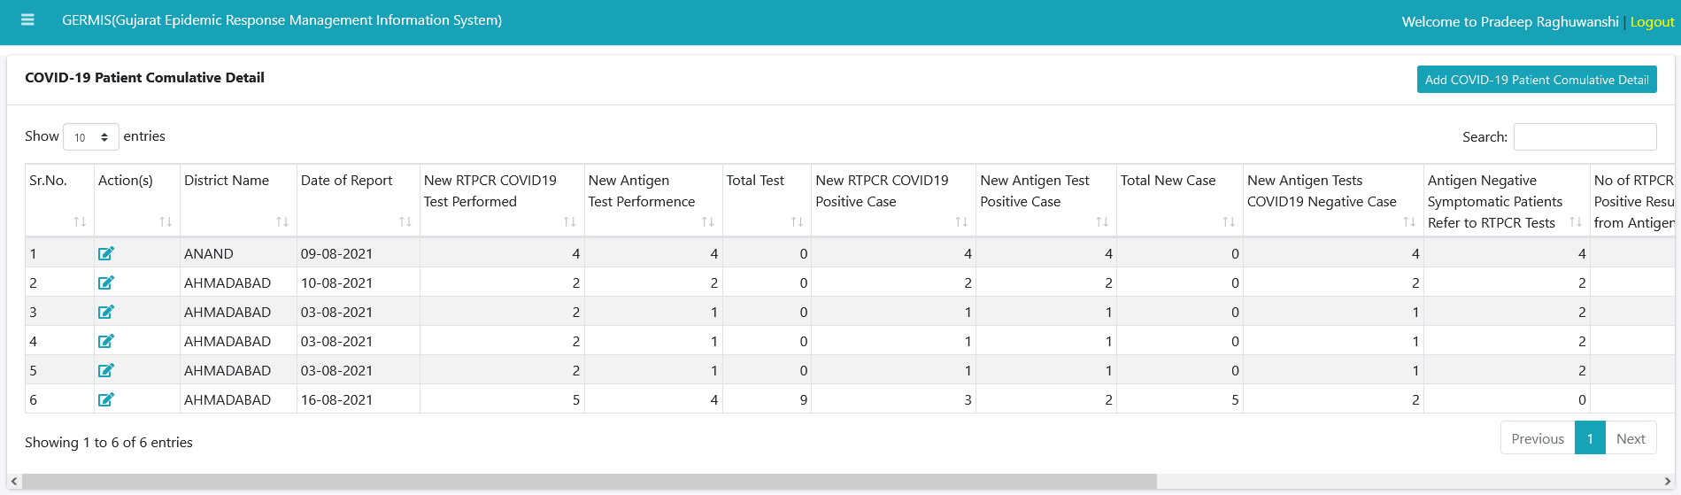

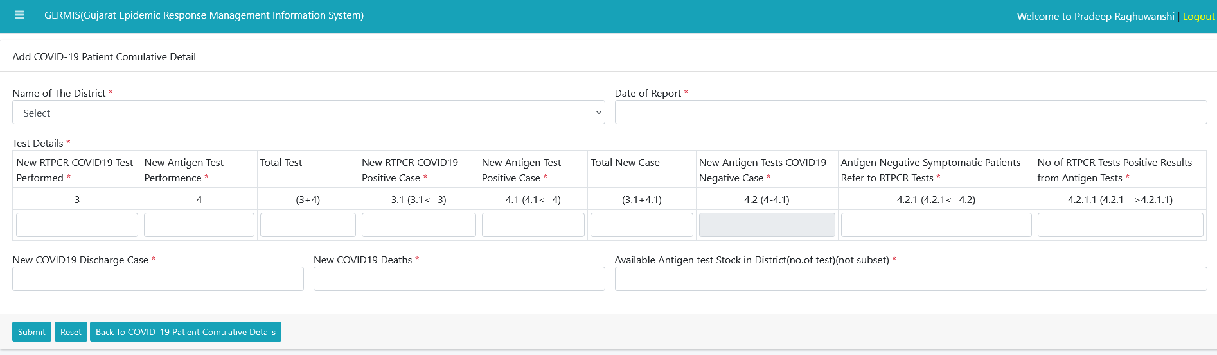We can check list of test’s performed for Covid 19 patient district wise.

We can add number of cases performed for Covid-19 in each district.

* 1. Positive case & Kit Cumulative detail (District Level Entry)



We can check list of positive cases available from specific laboratory district wise using this module.



We can add new case details district wise for particular laboratory using above module.

* 1. ILI & SARI Surveillance of NON Containment Zone Report (District Level Entry)

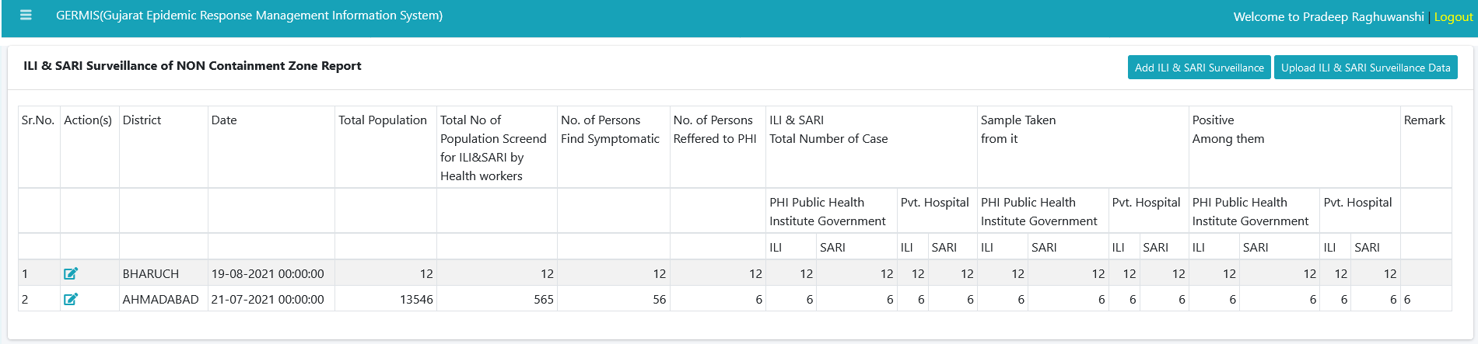

We can see details of Survey for Covid cases district wise whether any person has symptoms or whether any person is Covid positive.

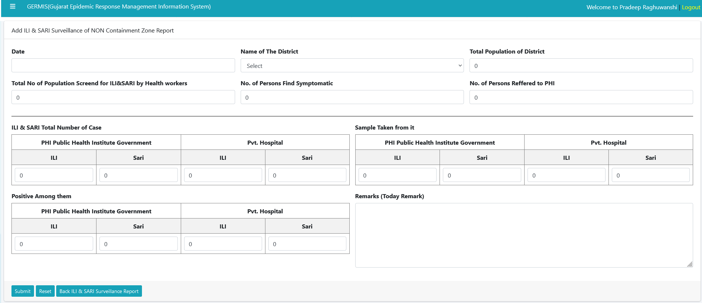

We can add details about survey conduct by health workers for find Sympatatic covid person’s district wise.

* 1. 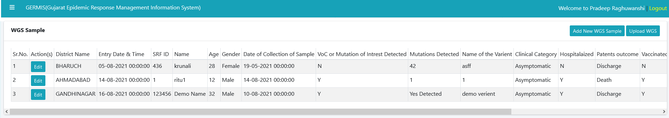Genome Sequencing Patient wise Details (District Level Entry)

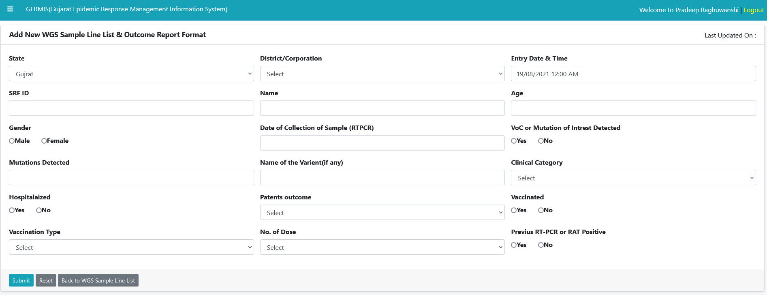We can see details of patients such as Vaccinated or not, Covid tested or not, Patient outcome etc.

We can add details of WGS samples according to patient using above Module. Same we can see patient wise result details using below Module (Genome Sequencing Patient wise result Details).

* 1. Genome Sequencing Patient wise result Details (District Level Entry)

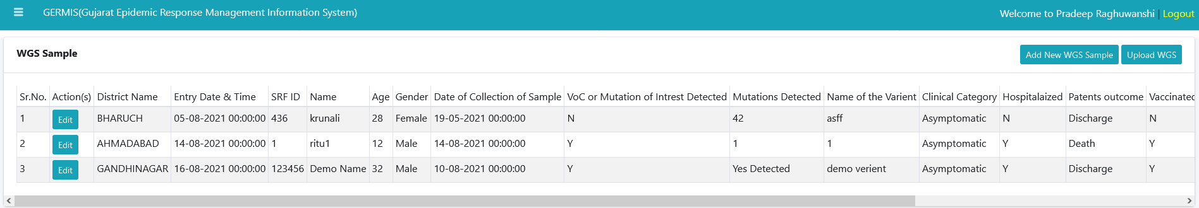

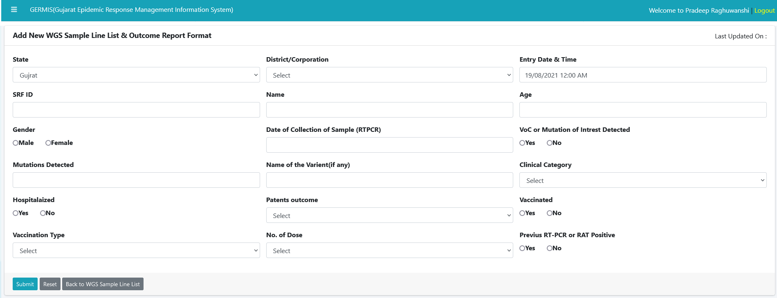

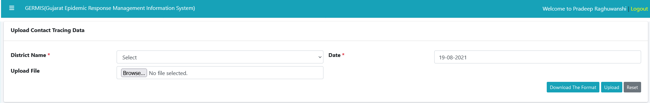8.14) Contact Tracing (District Level Entry)

We can check data/Reports district available AS on Date and it will display all records for contact tracing detected during transportation/travelling.

33



8.15) Vaccination Coverage (District Level Entry)

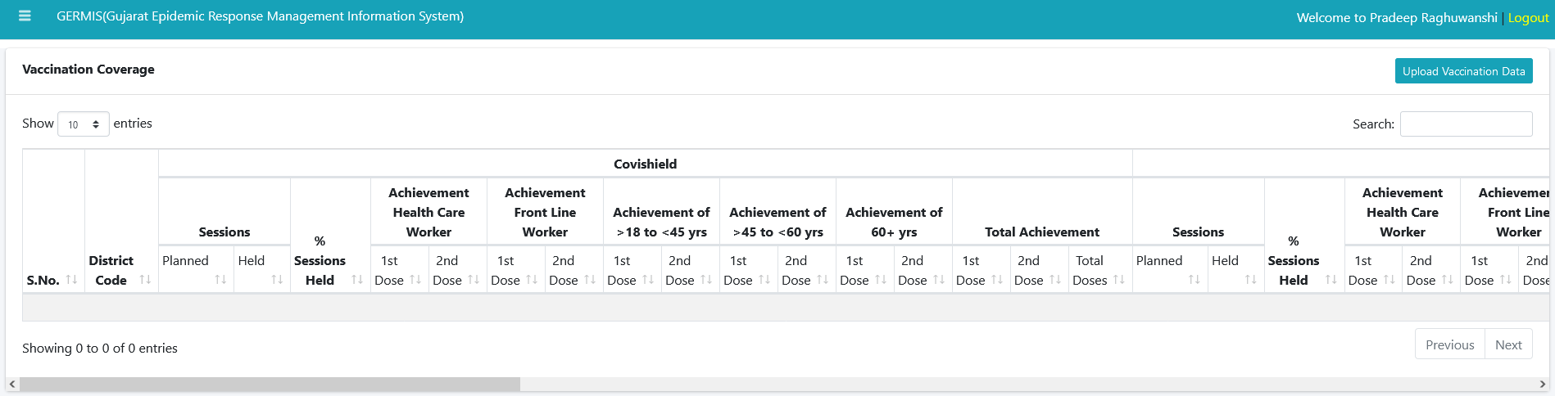

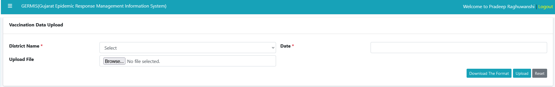

We can see report of vaccination done in district. We can see report dose wise in age group.

8.16) Containment Zone (District Level Entry)

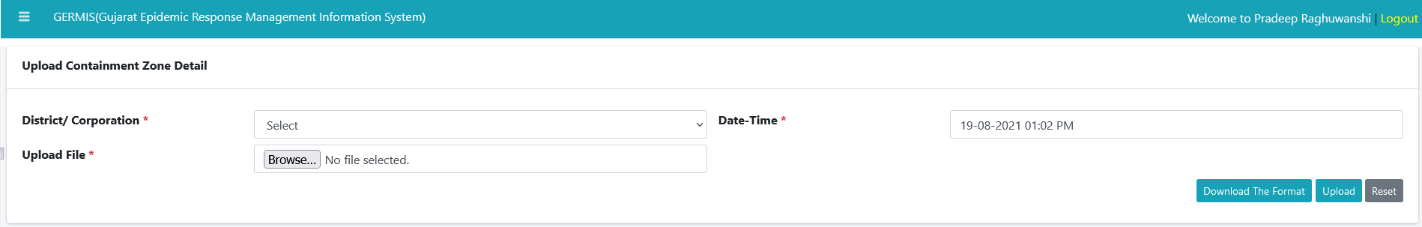

We can get records of containment zone district wise using above module for AS on Date.



9) Community Covid care center

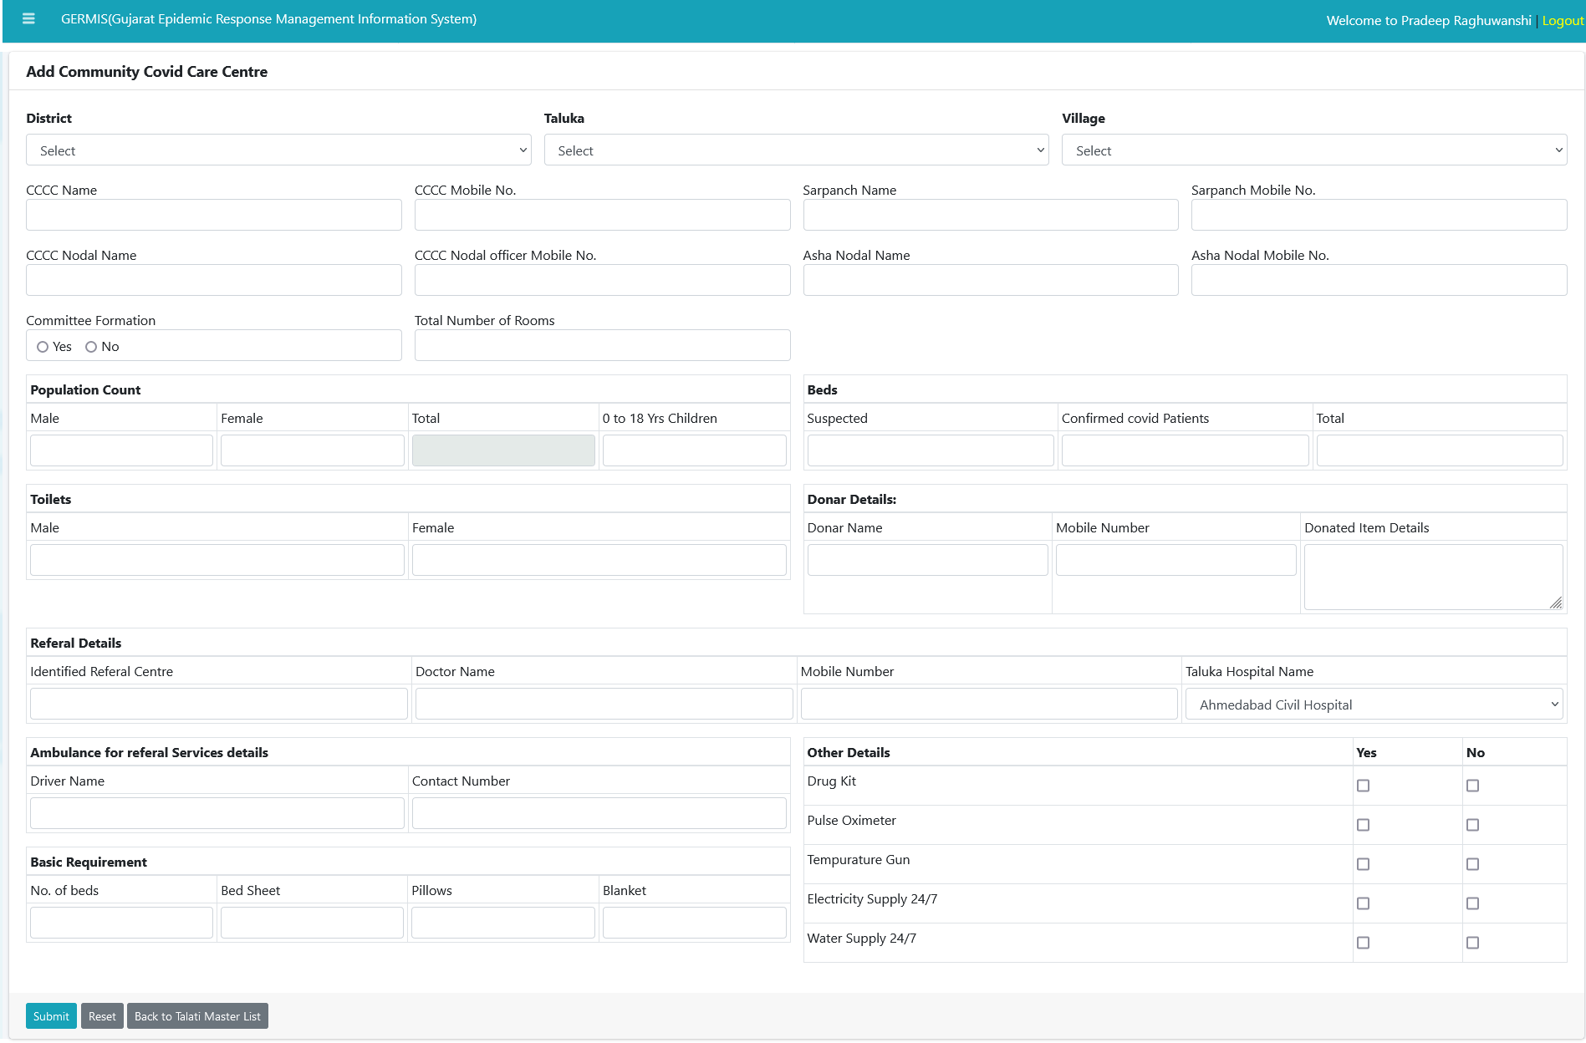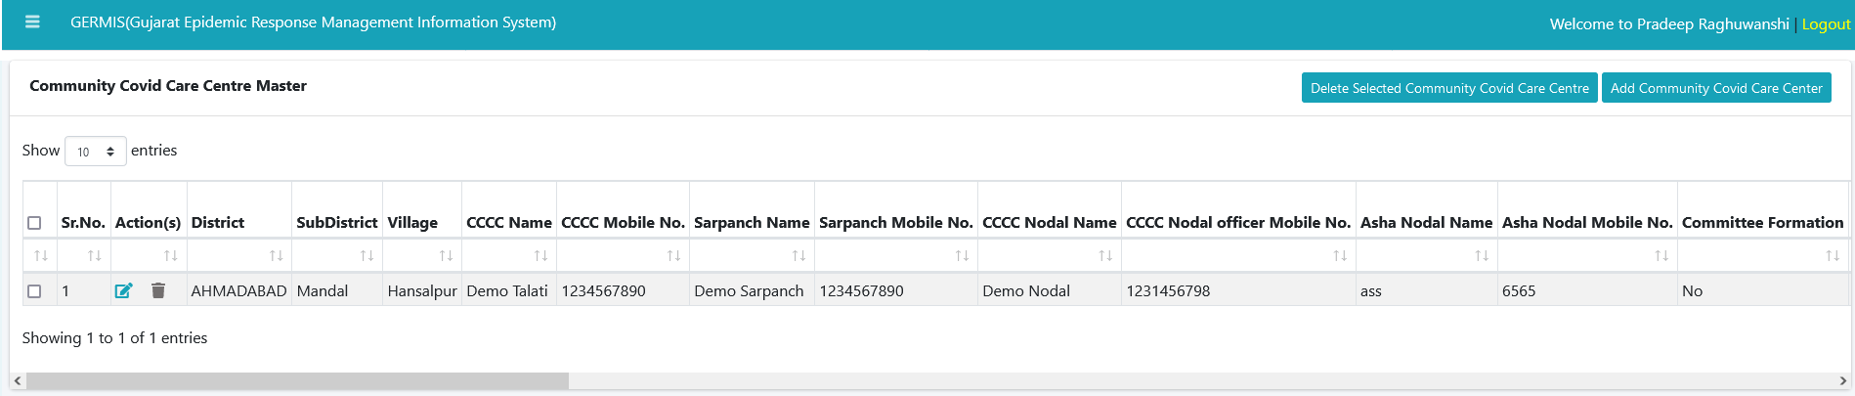9.1) Maru Gaam corona mukt Gaam (District Level Entry)

We can add requirement details for project “Maru Gaam Corona mukt Gam”. This above details need to add beds count, Population count, Basic Requirements (Drug kit, Pulse Oximeter, Temperature Gun, Electricity Supply, Water Supply etc.) provided by above Project.



9.2) Village Patient Details (Hospital Level Entry)

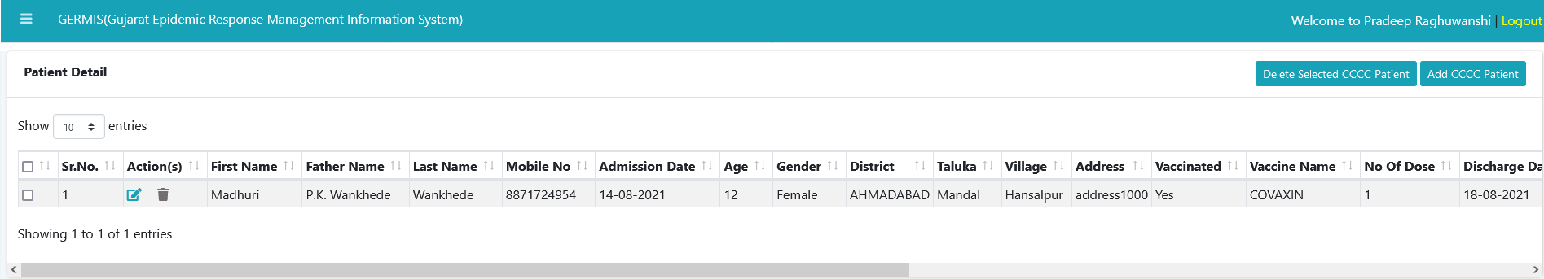

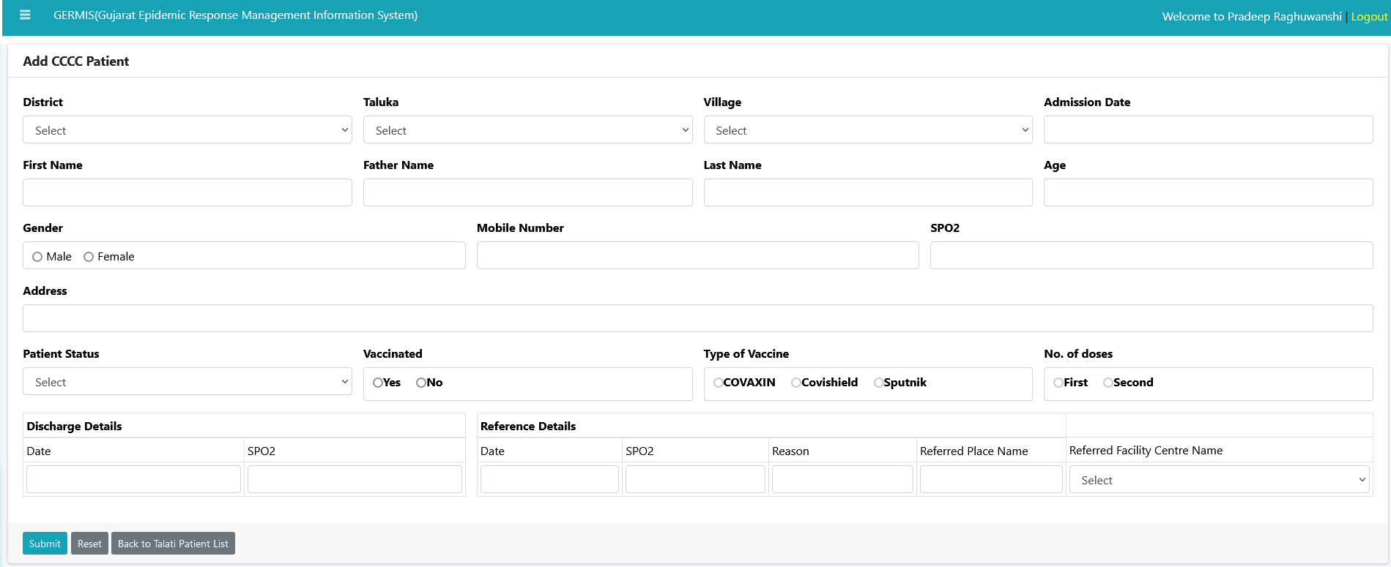

We can add patient details such as village wise and it can be added by Talati of particular village. Such as admitted date and discharge date etc.

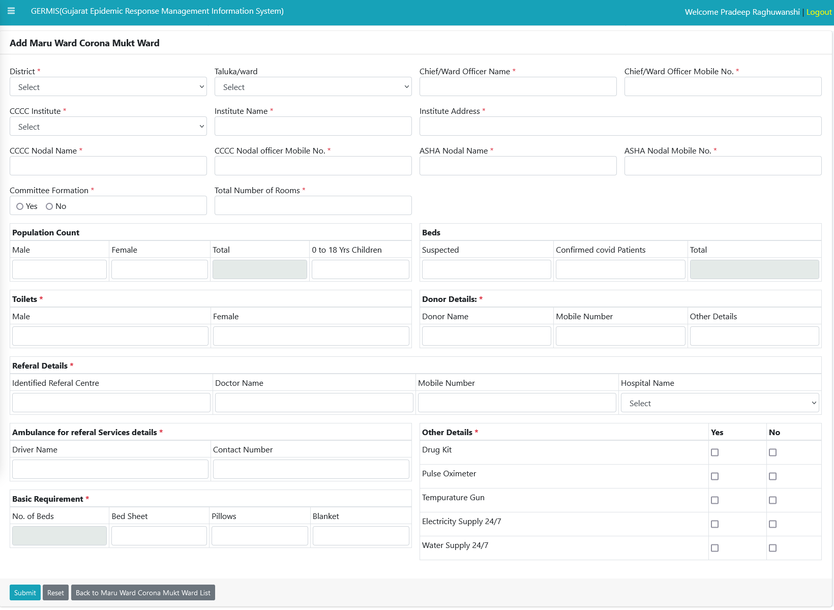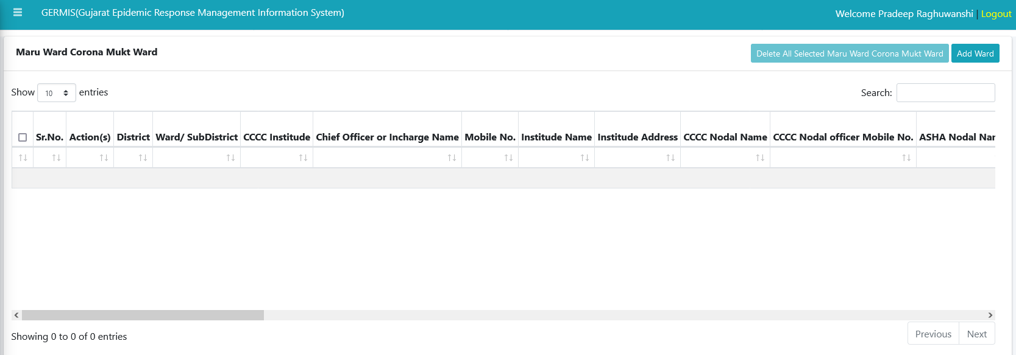9.3) Maru ward corona Mukt ward (Hospital Level Entry)

We can add taluka details about covid+ case and other such as population count, service provided in taluka or not.



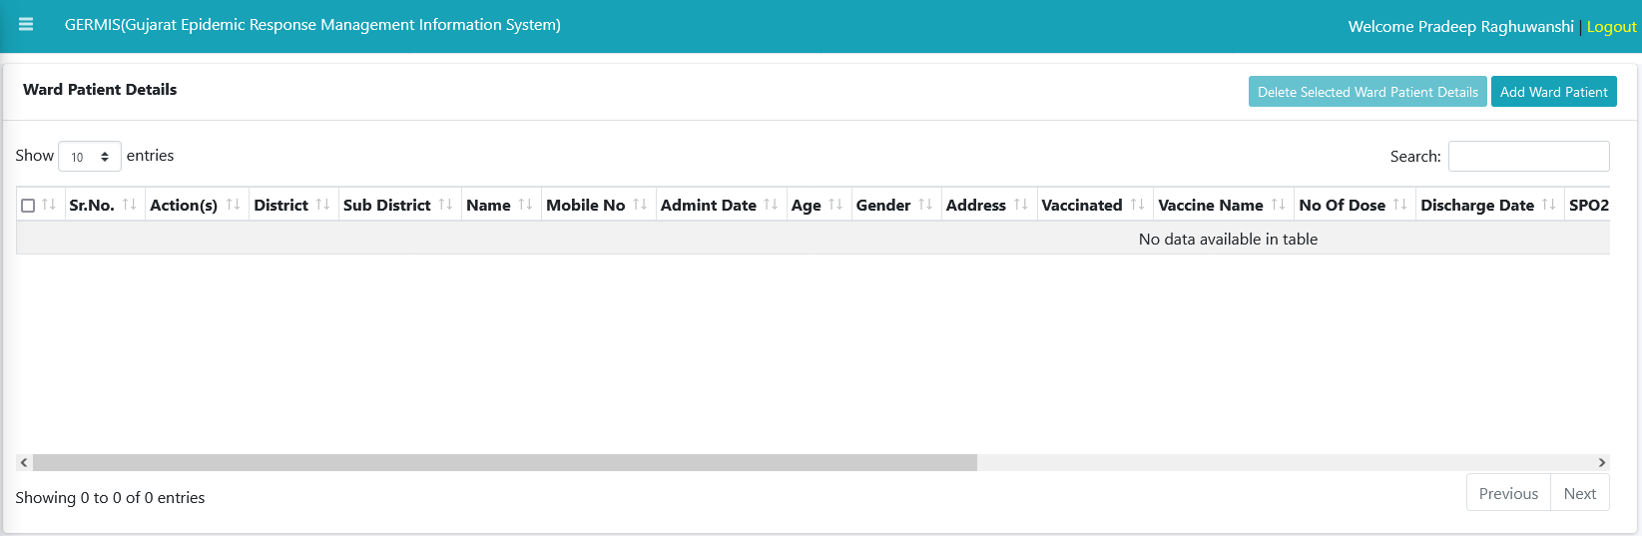9.4) Ward Patient details (Hospital Level Entry)

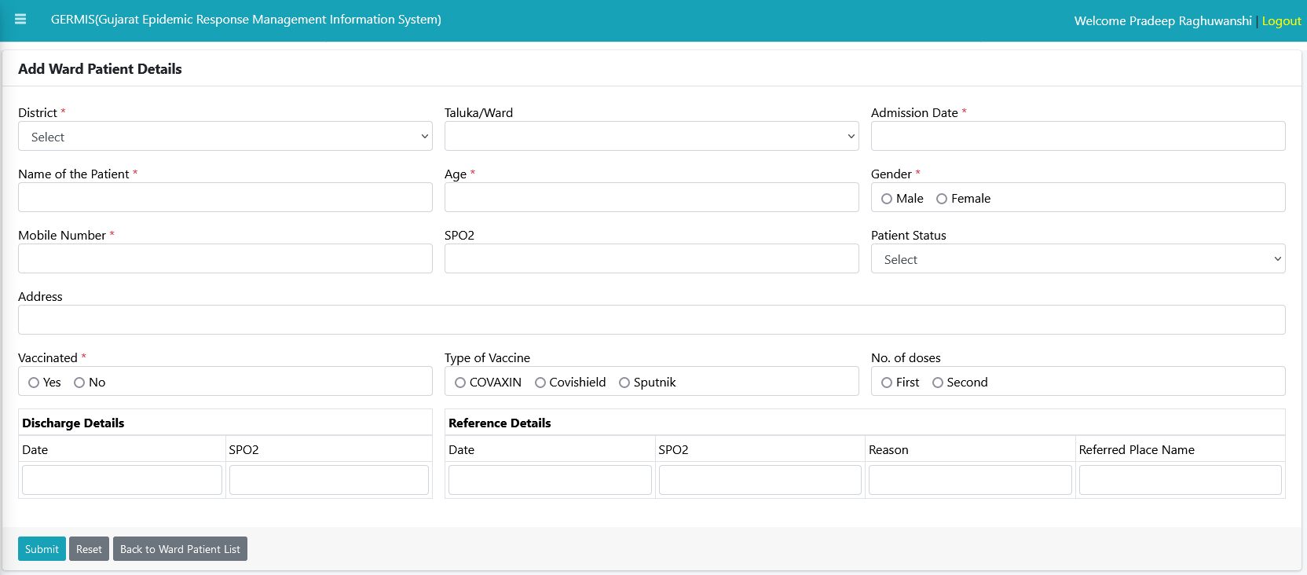

We can add taluka patient details using this module such as Patient vaccinated or not, discharge details etc.



10) Reports

We can get reports using above menu for below data Analysis.

1. Passenger Traveller Report
2. Active Case Summary
3. Bed Occupancy Details
4. Health Facility
5. ILI & SARI
6. Covid-19 Patient Commutative Details
7. Patient Death
8. Patient Discharge
9. WGS Sample Line
10. District Positive Case

We need to select FromDate and ToDate for get AS on Date records for each district.